Fotografías

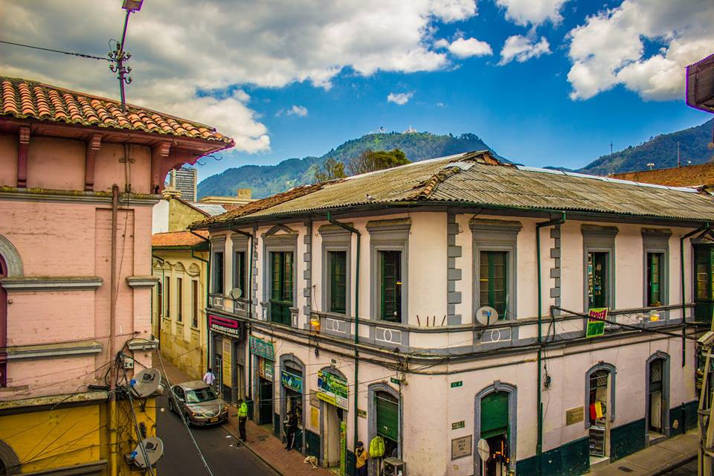

(FIG 1: Streetscape of the neighbourhood Centro Administrativo. Taken from the Facebook profile of ‘El Centro no se vende’. https://www.facebook.com/459418457470061/photos/ms.c.eJwlx8ENACAIBMGOzMEhi~;03ZozzGzqJ7KPCp2fxbkyUtvVfkkcEuuaICYc~-.bps.a.762712487140655.1073741864.459418457470061/762714003807170/?type=1&theater) Pág. 2
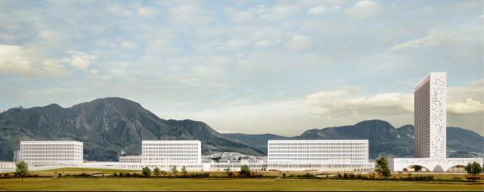
(FIG 2: Render of the winning proposal by architect Juan Pablo Ortiz. Taken from: http://www.empresavirgiliobarco.gov.co/proyectos/Paginas/ministerios.aspx) Pág. 10
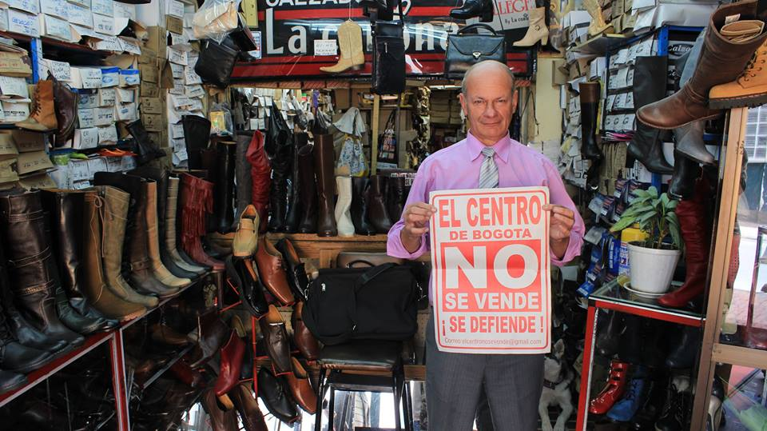
(FIG 3: One of the footwear businessmen in his shop, showing support to the community group. Taken from the Facebook profile of ‘El Centro no se vende’: https://www.facebook.com/459418457470061/photos/pb.459418457470061.-2207520000.1427408146./677588898986348/?type=3&theater) Pág. 14

