Additional Information for Publication
Título del artículo:
- Art’s Transformative Potential: Comparing Doris Salcedo’s Plegaria Muda and Ludmila Ferrari’s Cultus
- El efecto transformativo de dos obras de arte contemporáneo: Doris Salcedo’s Plegaria Muda y Ludmila Ferrari’s Cultus

Autor: Annatina Aerne
Curriculo abreviado: Please find my CV below
Phone: +41 (0)78 778 40 87
Address: Centro Latinoamericano-Suizo, Gatterstrasse 1, 9010 St.Gallen, Switzerland
Email: annatina.aerne@unisg.ch
Filiación institucional: PhD Candidate at the University of St.Gallen
Naturaleza del artículo: Artículo Reflexivo

Personal Information
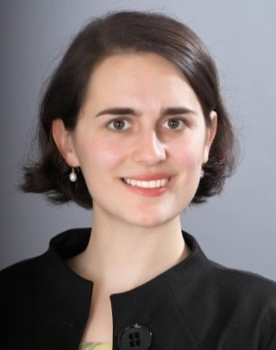
Name, First name Aerne, Annatina
Nationality Switzerland
Date of Birth 7.7.1989
Email annatina.aerne@unisg.ch
Mobile +41 78 778 40 87
Telephone +41 71 951 84 89

Education
St. Gallen, Switzerland University of St. Gallen
Sept. 2014 – Ph.D. programme in Organization Studies and Cultural Theory (DOK)
St. Gallen, Switzerland University of St. Gallen
Sept. 2010 – May 2014 Master of Arts in International Affairs and Governance
Medford, MA, United States The Fletcher School of Law and Diplomacy, Tufts University
Sept. 2011 – May 2014 Master of Arts in Law and Diplomacy
St. Gallen, Switzerland University of St. Gallen
Sept. 2007 – May 2010 Bachelor of Arts in International Affairs
Kingston, ON, Canada Queens School of Business, Queens University
Jan. 2010 – May 2010 Exchange Semester

Professional Experience
Zurich, Switzerland Swiss Re
Oct. 2013 – March 2013 Intern Sustainability and Political Risk
Bern, Switzerland Swiss Government, State Secretariat for Economic Affairs (SECO)
July 2012 – Jan. 2013 Intern for Swiss Export Risk Insurance (SERV)
St. Gallen, Switzerland Chair for Political Theory, University of St. Gallen
Sept. 2010 – Aug. 2011 Assistant at the Department of Political Theory
Brussels, Belgium economiesuisse, Federation of Swiss Business
Sept. 2009 – Oct. 2009 Intern for European Policy Issues

Language Skills
German, English, French, Spanish, Italian

Scholarships, Awards, Interests
Medford, MA, United States MacJannet Scholarship supporting interdisciplinary students
Sept. 2011 – May 2012 Scholar
Switzerland Swiss Study Foundation supporting excellent Swiss students
May 2008 – Member and chair of activities for the St. Gallen section in 2010
Zürich, Switzerland Swiss Youth Music Contest
June 2007 Winner of 2nd prize with classical guitar

