Synthesis of zeolites from kaolinite and metakaolinite in fluoride media under hydrothermal conditions

Carlos Alberto Ríos Reyes* and Craig Denver Williams**

*Geólogo y Especialista en Docencia Universitaria, Universidad Industrial de Santander, Bucaramanga, Colombia; Msc in Geology, Shimane University, Matsue, Japón; PhD in Applied Sciences, University of Wolverhampton, Wolverhampton, Inglaterra. Docente investigador, Escuela de Geología, Universidad Industrial de Santander, Bucaramanga, Colombia. carios@uis.edu.co
** BSc, MSc, PhD in Chemist, Salford University, Salford, Inglaterra. Professor, School of Applied Sciences, University of Wolverhampton, Wolverhampton, Inglaterra. c.williams@wlv.ac.uk

Abstract

The hydrothermal conversion of kaolinite and metakaolinite in a fluoride media was investigated in this study, with not promissory results, although traces of zeolitic products, such as faujasite (FAU), gismondine (GIS), chabazite (CHA), sodalite (SOD) and cancrinite (CAN) crystallized. The synthesis products are of interest as they can be used in several environmental applications.
Keywords: Hydrothermal conversion, kaolinite, metakaolinite, fluoride media, zeolitic products.

Sintesis de zeolitas a partir de caolinita y metacaolinita en medios fluorurados en condiciones hidrotermales

Resumen

En el presente estudio se ha investigado la conversión hidrotermal de caolinita y metacaolinita en un medio fluorurado, con resultados no promisorios, aunque cristalizaron trazas de productos zeolíticos, como faujasita (FAU), gismondina (GIS), chabazita (CHA), sodalita (SOD) y cancrinita (CAN). Los productos de la síntesis son de interés ya que pueden ser utilizados en diversas aplicaciones medioambientales.
Palabras clave: Conversión hidrotérmica, caolinita, metacaolinita, medios fluorurados, productos zeolíticos.

Introduction

Since the pioneering work of Barrer in the 1950s the conditions for zeolite synthesis have changed little. Zeolite synthesis has been extensively reviewed in several books and literature on this subject is abundant (Breck, 1974; Barrer, 1982; Jacobs and Martens, 1987; Szoztak, 1998). The general method of zeolite production involves dissolving an aluminium source (metal or oxide) into an alkaline solution. Most zeolites probably could be obtained at temperatures <100 °C in alkaline solutions. This is generally the case for zeolites with low Si/Al ratios. However, in order to reduce reaction times (especially for zeolites with high Si/Al ratios) and to control crystallite sizes, morphologies and compositions, some syntheses are performed at temperatures >100 °C under autogeneous pressure in autoclaves. Typical precursor materials include: SiO₂ and Al₂O₃ sources, mineralizer and structure directing agents (SDAs). The discovery of SDAs resulted in the preparation of nearly 100 different silicate frameworks (Ríos, 2008). Other synthetic variables including the source of the inorganic precursors, the mineralizing agent (OH⁻ or F⁻) and the reactant concentrations have also resulted in new crystalline materials. Corma (2004), using F⁻ as mineralizing agent allows one to carry out the synthesis at lower pH than when using OH⁻, and opens new possibilities such as: The incorporation of elements in the framework which have low solubility in alkaline medium, to perform the synthesis in absence of alkaline cations, new possibilities to directly incorporate cations such as NH₄⁺, divalents, adequate stability of many possible templates in this medium, expanding the number of potential templates especially when working with concentrated gels. Finally, the synthesis in the presence of fluoride produces high silica zeolites with a smaller number of defects than in alkalin media and also one has the possibility of growing single crystals large enough for direct structure determination. The use of fluoride as a mineralizer in zeolite synthesis was developed by Flanigen (1973) and has resulted in zeolites being prepared with fewer defect sites and higher silica contents. In the synthesis of zeolites, fluoride ions are generally known to play a mineralizing role, as does OH– in alkaline synthesis conditions (Tavolaro et al., 1992; Rees and Chandrasekhar, 1993; Férona et al., 1994; Koller et al., 1999; Barret et al., 1998; Serrano et al., 2001; Kato et al., 2003). Zeolite synthesis in fluoride-containing media has been studied in connection with the possibility of giving larger zeolite crystals than those without the fluoride species in the synthesis solution and to increase the pH range over which zeolites may be synthesized (Tavolaro et al., 1992; Kim et al., 2004). Additionally, several groups have reported a catalytic role of fluoride species for silicate hydrolysis and condensation (Schmidt-Winkel, et al., 1999). Kim et al. (2004) developed the synthesis of zeolite beta in fluoride media under microwave irradiation as an efficient and fast route of synthesis. The synthesis of crystalline aluminosilicate zeolites can be carried out from clay minerals (Breck, 1974; Barrer et al., 1974; Boukadir et al., 2002; Klimkiewicz and Drąg, 2004; Baccouche et al., 1998; Cañizares et al., 2000; Boukadir et al., 2002). Previous work has shown that the improvement of the properties of the kaolinite by chemical methods is difficult due to its low reactivity. It is not significantly affected by acid or alkaline treatments, even under strong conditions (Lussier, 1991; Murat et al., 1992; Akolekar et al., 1997; Perissinotto et al., 1997; Chandrasekhar and Pramada, 1999; Demortier et al. 1999; Xu et al., 1999). Therefore, kaolinite is usually used after calcination at temperatures between 550-950 °C (Mackenzie, 1970) to obtain a more reactive phase (metakaolinite) under chemical treatments, with the loss of structural water and associated reorganization of the structure. Several authors have reported the synthesis of kaolinite- and metakaolinite-based zeolitic materials (e.g., Chorover et al., 2003; Zhao et al., 2004; Lin et al., 2004; Covarrubias et al., 2006; Ríos et al., 2009). Numerous investigations have been conducted on the stability of kaolinite in high pH conditions (e.g., Bauer and Berger, 1998; Bauer et al., 1998; Cama et al., 2000). Rees and Chandrasekhar (1993) have converted kaolinite and metakaolinite into zeolites by hydrothermal reaction in fluoride media. When a fluoride medium was used, kaolinite gave zeolite-GIS directly without any intermediate metastable phase; whereas zeolite-FAU was the stable intermediate from metakaolinite.

1. Experimental

1.1 Materials

The silica and alumina sources used in the synthesis of zeolites were kaolinite and metakaolinite. Well crystallized, fine grained kaolinite (≤ 2 μm), Al₂SiO₅(OH)₄, was used as the starting material for zeolite synthesis. It is distributed under the name Supreme Powder supplied by ECC International. Metakaolinite (Al₂Si₂O₇) was obtained from calcination of kaolinite. Other reagents used in the activation of the starting materials were: sodium fluoride, NaF (99%, Fluka), ammonium fluoride, NH₄F (98+%, A.C.S., Aldrich Chemical Company, Inc.), tetrapropylammonium bromide, (CH₃CH₂CH₂)₄NBr (98 %, Aldrich Chemical Company, Inc.) and distilled water using standard purification methods.

1.2 Synthesis of zeotypes

Poor crystalline zeotypes have been synthesized after hydrothermal treatment of kaolinite or metakaolinite in fluoride media. The conversion of these raw materials into zeolitic materials was conducted by the conventional hydrothermal synthesis method. The fluoride media was prepared by dissolving the activating agents (NaF or NH₄F) in distilled water under stirring conditions in plastic reaction beakers (150-250 ml). The use of several mineralizers is justified by the fact that it is interesting to compare their effect and efficiency in the synthesis process. Calculated amounts of the raw materials were added to the activating solutions and stirred until the reagents were dissolved and for the homogenization of the reaction mixture. When NH₄F was used as mineralizer, TPAB was added to the reaction mixture to investigate the formation of silica-rich zeolites in slight acidic media. Then, the pH of the reaction gels was measured. The representative gel molar compositions are depicted in Table 1. The crystallization was carried out by hydrothermal synthesis under static conditions in PTFE (polytetrafluoroethylene = Teflon) bottles (Cowie Technology Ltd) of 65 ml at 100°C and in teflon lined stainless steel autoclaves of 20 ml at 175°C for several reaction times. The reactors were removed from the oven at the scheduled times and were quenched in cold water for product identification. Then, pH of the reaction mixtures was measured. After hydrothermal treatment, the reaction mixtures were filtered, washed with distilled water, and the products were dried in an oven at 80°C. The dried samples were weighted and kept in plastic bags for analysis.

Table 1. Synthesis conditions for conversion of the raw materials into zeolite phases in fluoride media.

1.3 Characterization

The starting materials and the synthesis products were characterized by several instrumental analysis techniques. Powder X-ray diffraction (XRD) patterns were obtained on a Philips PW1710 diffractometer operating in Bragg-Brentano geometry with Cu-Kα radiation (40 kV and 40 mA) and secondary monochromation. Data collection was carried out in the 2θ range 3-50°, with a step size of 0.02°. Phase identification was made by searching the ICDD powder diffraction file database, with the help of JCPDS (Joint Committee on Powder Diffraction Standards) files for inorganic compounds. Fourier transform infrared (FTIR) spectroscopy was carried out using a Mattson Genesis II FT-IR spectrometer in the 4000-400 cm-1 region. The morphology of the starting material and as-synthesized products was studied with a ZEISS EVO50 scanning electron microscope, under the following analytical conditions: I probe 1 nA, EHT = 20.00 kV, beam current 100 μA, Signal A = SE1, WD = 8.0 mm. Thermogravimetric and differential thermal analyses were performed on a Mettler Toledo TG 50 thermobalance. Samples ~ 15-20 mg were heated under nitrogen gas flow (20ml/min) between 25-700ºC at a rate of 20ºC/min.

2. Results and discussion

2.1 X-ray diffraction analysis

Figure 1 illustrates the X-ray diffraction patterns for the results of hydrothermal synthesis from the natural clay in solutions of NaF (1.33M). Kaolinite (in red color) is the predominant mineral phase, which can be identified by its characteristic XRD peaks at 12.34° and 24.64° 2θ as reported by Zhao et al. (2004). However, minor impurities, such as illite, muscovite and halloysite, also occur. Metakaolinite (in red color) is characterized by the disappearance of all the XRD peaks of the natural clay, accompanied by the appearance of an amorphous aluminosilicate (see the broad hump at 2θ = 13-33°, having a maximum at 2θ = ∼22º), which according to Ríos (2008), persists between 600 and 950 ºC. As can be seen also from the XRD patterns, a slow dissolution of the starting materials, revealed by a progressive reduction of the peak intensity, was accompanied by the appearance of very weak peaks of zeolite Na-P1 (GIS), chabazite (CHA) and Linde Type Y (FAU), which increased in crystallinity with reaction time, although with a large amount of amorphous aluminosilicate material when metakaolinite was used.

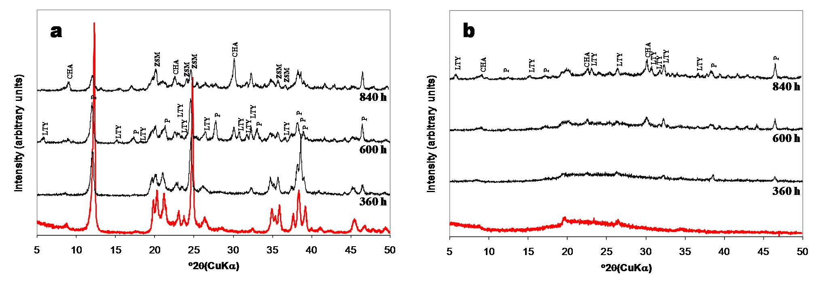Figure 1. XRD patterns of the starting materials (in red color) and the as- synthesized products obtained after hydrothermal treatment of (a) kaolinite and (b) metakaolinite in 1.33M NaF solutions at 100ºC for several reaction times. P, zeolite Na-P1 (GIS); R, chabazite (CHA), LTY, Linde Type Y (FAU).

The XRD patterns in Figure 2 show a very slow dissolution of kaolinite and a formation of amorphous aluminosilicate material when low and high concentrations of the mineralizer (NH₄F) were used, respectively, and higher temperatures of crystallization. Figure 2a reveals that the synthesis products include zeolite Na-P1 (GIS), cancrinite (CAN), sodalite (SOD) and Linde Type A (LTA). Figure 2b shows the formation of these zeotypes, although with weak peak intensity.

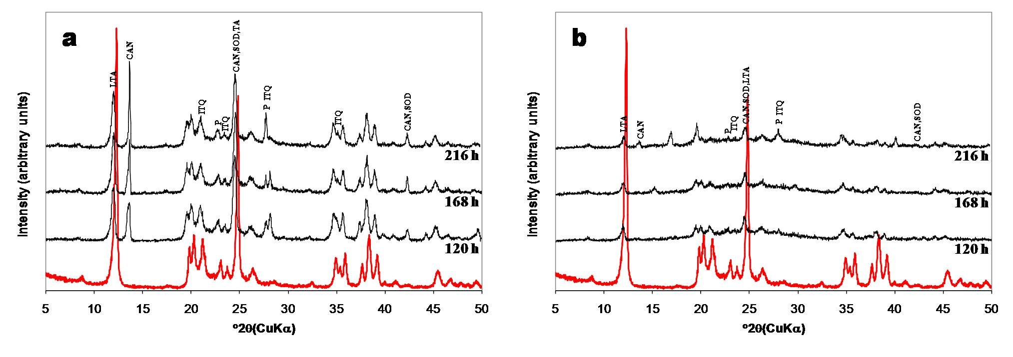
Figure 2. XRD patterns of the raw kaolinite (in red color) and the as-synthesized products obtained after hydrothermal treatment in (a) 1.33M and (b) 3.99M NH₄F solutions at 175ºC for several reaction times. C, cancrinite (CAN); S, sodalite (SOD); LTA, Linde Type A (LTA); P, zeolite Na-P1 (GIS).

2.2 Fourier transformed infrared spectroscopy

Figure 3 illustrates the FT-IR spectra of the starting materials over the range 400–4000 cm⁻¹. The bands at 3692 and 3619 cm⁻¹ have been assigned to the stretching vibration of hydroxyl groups in the kaolinite structure (Liu et al., 2001; Saikia et al., 2003; Zhao et al., 2004; Alkan et al., 2005) which are not present in the metakaolinite spectrum. However, the bands at 3669 and 3652 cm cm⁻¹ reported by Zhao et al. (2004) and Hoch and Bandara (2005) were not observed. According to Kristof et al. (1993), the band at 3692 cm⁻¹ represents the stretching vibration modes of inner surface hydroxyls that are located at the surface of octahedral sheets opposite to the tetrahedral oxygens of the adjacent kaolinite layer, whereas the band at 3619 cm⁻¹ is related to the stretching vibration modes of inner hydroxyls and refer to OH groups located in the plane common to octahedral and tetrahedral sheets. The band at 1119 cm⁻¹ is referred to Si-O stretching vibrations, while the bands at 1034 and 1012 cm⁻¹ are caused by Si-O-Si and Si-O-Al lattice vibrations (van der Marel and Beutelspacher, 1976). The OH bending vibrations at 942 and 916 cm⁻¹ can be referred to the surface OH bending and inner OH bending (Frost et al., 2002). According to van der Marel and Beutelspacher (1976), these bands are mainly caused by Al-OH groups. Further, bands in low range of frequency (762, 696 and 539 cm⁻¹) can be largely attributed to different Si-O and Al-O vibrations; the first two of them can be attributed to the distortion of the tetrahedral and octahedral layers (Hoch and Bandara, 2005). The conversion of kaolinite to metakaolinite is revealed by the disappearance of these characteristic bands. These changes are similar to those reported in other studies (Akolekar et al., 1997; Zhao et al., 2004; Covarruvias et al., 2006). The characteristic bands observed in the metakaolinite were 1049, 802, 642, 571 and 434 cm⁻¹, with three broad bands centred at 1049, 802 and 434 cm⁻¹. A significant shift of the Si-O vibration bands at 1034 and 1012 cm⁻¹ in kaolinite to a higher frequency band at 1049 cm⁻¹ in metakaolinite was observed, which has been assigned to amorphous SiO₂, as reported by some authors (Sinha et al., 1995; Valcke et al., 1997; Qiu et al., 2004). The stretching vibration of Al (O,OH)₆ octahedra in the kaolinite (Lambert et al., 1989) is observed at 539 cm⁻¹, but is substituted by a peak at 582 cm⁻¹ corresponding to the vibration band of AlO₄ tetrahedron in metakaolinite; these peaks indicate the formation of the disordered metakaolinite phase.

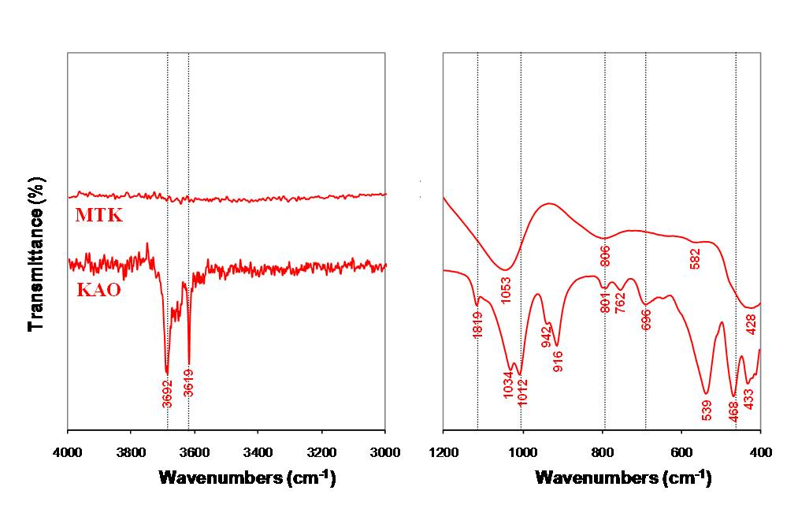
Figure 3. FTIR spectra of the raw materials used in the synthesis of zeolites.

The FT-IR spectra over the range 400–4000 cm⁻¹ corresponding to the transformation of kaolinite and metakaolinite in NaF solutions are illustrated in Figure 4. The characteristic peaks for the pre-existing starting materials did not disappear, although they weakened with longer reaction times.

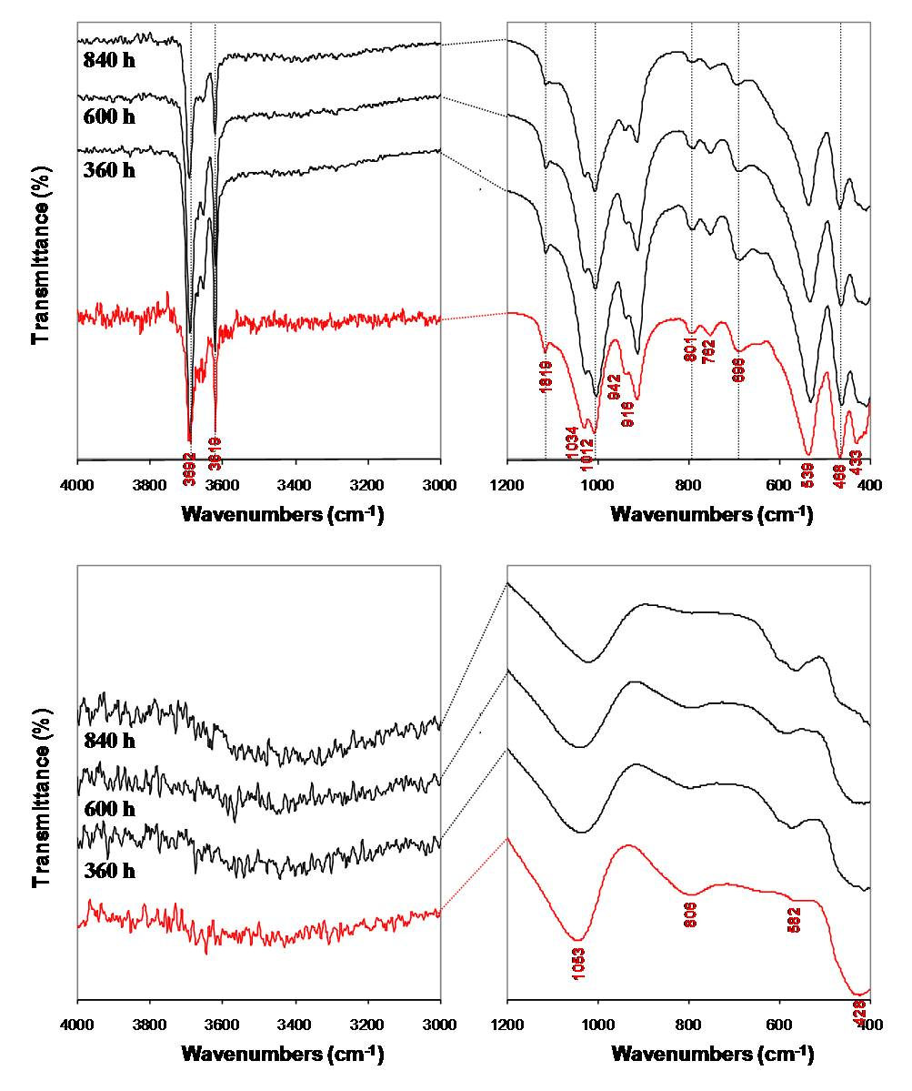
Figure 4. FTIR spectra of raw materials (in red color) and as-synthesized products obtained after their hydrothermal treatment in 1.33M NaF solutions at 100ºC for several reaction times; kaolinite, upper part; metakaolinite, lower part.

2.3 Scanning electron microscopy

SEM micrographs of representative synthesis products obtained after hydrothermal reaction of the starting materials in fluoride media are illustrated in Figures 5-7. As shown in Figure 5, only spheroidal and flower-like morphologies as well as the relict kaolinite flaky crystals are observed, but not the characteristic morphologies of zeolites Na-P1, Linde Type Y and chabazite. Figure 6 shows spheroidal morphologies and relict flaky crystals of the starting material, as well as a dodecahedral crystal, displaying a typical cubic symmetry and simple twinning, from which flaky aggregates grow. As shown in Figure 7, the transformation of kaolinite in NH₄F solutions using SDA promoted the formation of sodalite and cancrinite. According to Kuperman et al. (1993), a fluoride-containing medium in the hydrothermal synthesis of zeolites promotes the formation of larger zeolite crystals than those without the use of fluoride species. Taking into account the XRD results and the morphology of the synthesis products observed in SEM, we propose that under the hydrothermal conditions in fluoride media, smaller zeolite crystals are produced in the presence of fluoride ions than those in the absence of fluoride ions as suggested by Kim et al. (2004). They consider that the addition of fluoride leads to the smaller particles of zeolite due to an increase of the nucleation rate followed by the shortening of the crystallization time.
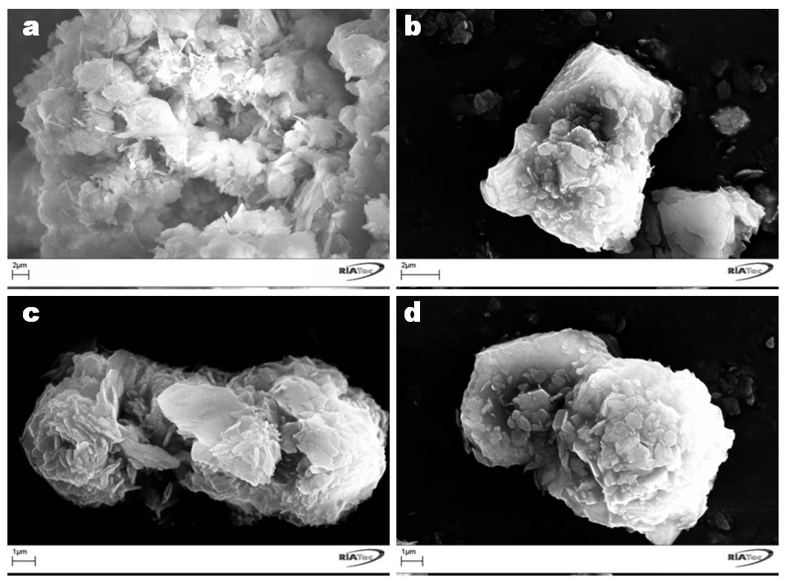Figure 5. SEM images showing morphological aspects in as-synthesized products obtained after hydrothermal treatment of kaolinite (upper part) and metakaolinite (lower part) in 1.33M NaF solutions at 100ºC for 840 h of reaction time.

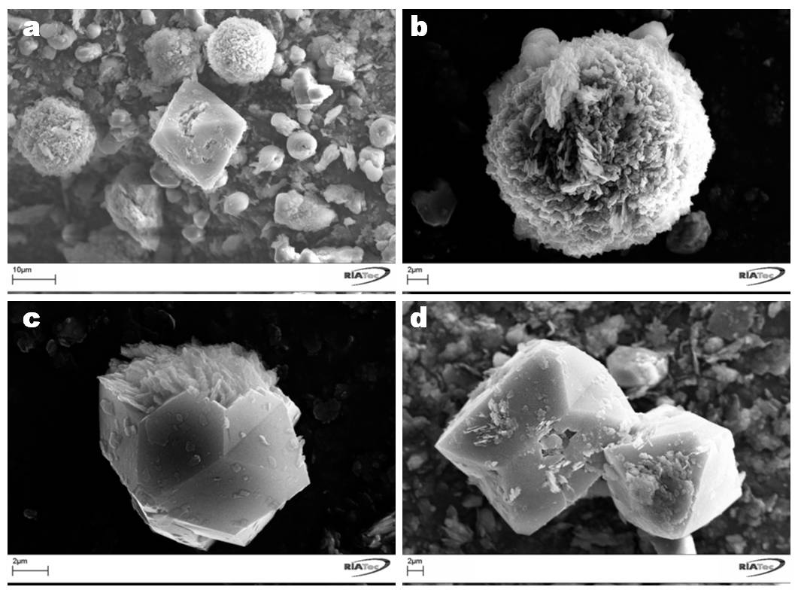Figure 6. SEM images showing morphological aspects in as-synthesized products obtained after hydrothermal treatment of kaolinite in 1.33M NH₄F solutions at 175ºC for 216 h of reaction time.

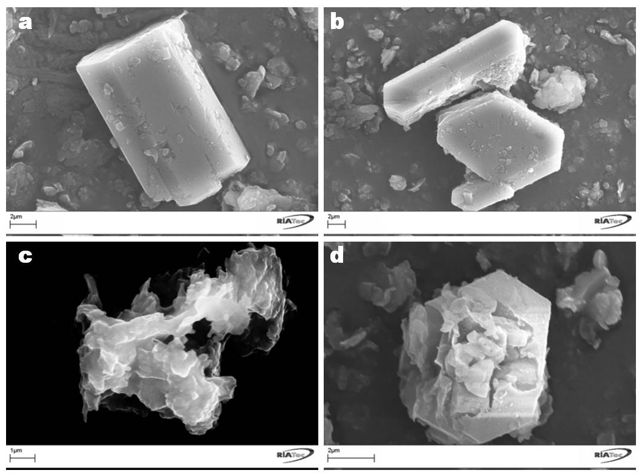Figure 7. SEM images showing morphological aspects in as-synthesized products obtained after hydrothermal treatment of kaolinite in 3.99M NH₄F solutions at 175ºC for 216 h of reaction time.

2.4 Thermogravimetric analysis

It is well known that the improvement of the properties of kaolinite by chemical methods is difficult due to its low reactivity (Ríos, 2008). Although the thermal transformation of kaolinite has been investigated for many years, controversy about the process of dehydroxylation (elimination of the OH groups from the kaolinite structure) remains. The thermal decomposition of kaolinite is illustrated in the TGA and its first derivative (DTG) curves on Figure 8 and can be summarized by a sequence of reactions. At < 100 ºC, low temperature release of absorbed water in pores, on the surfaces, etc (water desorption), which depends on the nature of the kaolinite and the degree of disorder of stacking (Frost et al., 2003). Between ∼100–400 °C, a weight loss that can be correlated with a pre-dehydration process takes place as a result of the reorganization in the octahedral layer, first occurring at the OH of the surface (Balek and Murat, 1996). After dehydration, kaolinite goes through a pre-dehydroxylation state (Frost et al., 2003). According to Kakali et al. (2001), between ∼400–650 °C, the kaolinite dehydroxylation occurs, with the transformation to a non-crystalline phase, metakaolinite. On the other hand, Frost et al. (2003) considered that this process occurred between 450-550 ºC.

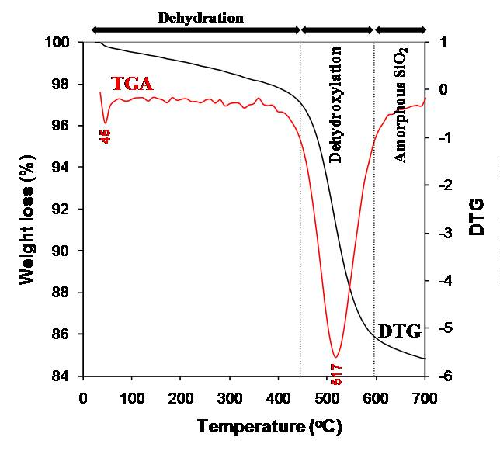
Figure 8. TG/DTG curves between 25-700ºC for kaolinite.

The TGA and its first derivative (DTG) curves for representative synthesis products are illustrated in Figure 9. These curves in the presence of fluoride ions exhibit several peaks, which could be generally correlated with different dehydration steps: 23-140, 140-220 and 400-600 ºC. The position of these DTG peaks and the number of dehydration steps may be attributed to the different compensating cation-water binding energies, as well as to the different energy associated with the diffusion of the desorbed water through the porous structure of the zeolitic materials (Ríos, 2008). Their weight loss percentages reflect the water loss from the zeolite structure, and the amount of desorbed water is related with the number of compensation cations in the zeolite framework (Covarrubias et al., 2006). The peaks observed between 23-140 ºC are due to the desorption of the occluded water in zeolitic materials (zone I). The presence of zeolitic water is revealed by the peak between 140-220 ºC (zone II). The peak in the zone III may be considered to be correlated with charge compensation between zeolite cations and fluoride ions, and incorporation of fluoride ions located in small cages within the zeolite framework as suggested by Camblor et al. (1998). The framework containing Al species (zone IV). The dehydroxilation of the zeolitic material is registered between 600-700 ºC (zone V).

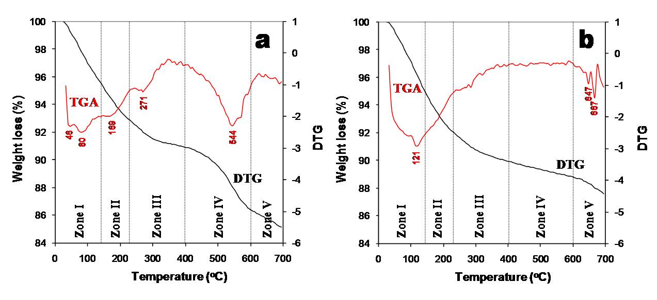Figure 9. TG/DTG curves between 25-700ºC for the as-synthesized products obtained after hydrothermal treatment of (a) kaolinite and (b) metakaolinite in 1.33M NaF solutions at 100ºC for 840 h of reaction time.

3. Conclusions

This research shows the results of the hydrothermal transformation of kaolinite and metakaolinite in fluoride media, the influence of crystallization time and temperature and SDA addition on the formation process. Attempts to synthesise zeolitic materials from kaolinite and metakaolinite in fluorine solutions have so far not been successful, resulting in greater impurity and/or poorer crystallinity. The authors used fluoride media, taking into account that during the synthesis process the F ions allowed reducing of the level of Na and K ions to only those present in the starting materials. The gel chemistry is completely different here, providing a further opportunity to prepare new zeolites, but the pH of fluoride-containing gels should be neutral-to-acidic, which was not obtained in the experiments (pH = 10.4-12.2) probably because the experimental conditions were not appropriated as revealed by the occurrence of relitic phases of the raw materials along with a poorly crystallized mixture of several zeotypes. At higher mineralizer concentration, the addition of SDA and increasing the crystallization temperature promoted the formation of an amorphous product. Therefore, the results have been disappointing, in respect to those obtained by other authors.

Acknowledgements

This work was supported by the Programme Alban, the European Union Programme of High Level Scholarships for Latin America (Scholarship No. E05D060429CO) and the Universidad Industrial de Santander. Special thanks to School of Applied Sciences at University of Wolverhampton for allowing us the use of the research facilities. The authors also thank Dr. David Townrow, Mrs Diane Spencer, Mrs Barbara Hodson and Mr. Keith Thompson for assistance with the acquisition of analytical data. We are most grateful to the above-named people and institutions for support.

References

AKOLEKAR, D.; CHAFFEE, A. and HOWE, R.F. The transformation of kaolin to low-silica X zeolite, Zeolites. 1997, vol. 19, núm. 5, pp. 359-365.
ALKAN, M.; HOPA, C.; YILMAZ, Z. and GULER, H. The effect of alkali concentration and solid/liquid ratio on the hydrothermal synthesis of zeolite NaA from natural kaolinite. Microporous and Mesoporous Materials. 2005, vol. 86, núm. 1-3, pp. 176-184.
BACCOUCHE, A.; SRASRA, E. and MAAOUI, M.E. Preparation of Na-P1 and sodalite octahydrate zeolites from interstratified illite–smectite. Applied Clay Science. 1998, vol. 13, núm. 4, pp. 255-273.
Balek, V. and Murat, M. (1996). The emanation thermal analysis of kaolinite clay minerals. Thermochimica Acta 282-283, 385–397.
BARRER, R.M. Hydrothermal Chemistry of Zeolites, 1st ed., London: Academic Press, 1982. 360 p. ISBN 0-12-079360-1360.
BARRER, R.M.; COLE, J.F. and STICHER, H. Chemistry of soil minerals. Part V. Low temperature hydrotermal transformations of kaolinite. Journal of the Chemical Society A: Inorganic, Physical, Theoretical. 1968, pp. 2475-2485.
Barrett, P.A.; Camblor, M.A.; Corma, A.; Jones, R.H. and Villaescusa, L.A. Synthesis and Structure of As-Prepared ITQ-4, A Large Pore Pure Silica Zeolite: The Role and Location of Fluoride Anions and Organic Cations. The Journal of Physical Chemistry B. 1998, vol. 102, núm. 21, pp. 4147 4155.
Bauer, A. and Berger, G. Kaolinite and smectite dissolution rate in high molar KOH solutions at 35 ° and 80 °C. Applied Geochemistry. 1998, vol. 13, núm. 7, pp. 905-916.
Bauer, A.; Velde, B. and Berger, G. Kaolinite transformation in high molar KOH solutions. Applied Geochemistry. 1998, vol. 13, núm. 5, pp. 619-629.
Boukadir, D.; Bettahar N. and Derriche, Z. Synthesis of zeolites 4A and HS from natural materials. Annales de Chimie Science des Matériaux. 2002, vol. 27, núm. 4, pp. 1-13.
BRECK, D.W. Zeolite Molecular Sieves: Structure, Chemistry and Use, 1st Ed., New York: John Wiley, 1974. 313 p. ISBN 10-0-471-09985-6.
CAMA, J.; AYORA, C.; QUEROL, X. and GANOR, J. Dissolution kinetics of synthetic zeolite NaP1 and its implication to zeolite treatment of contaminated waters. Environmental Science and Technology. 2005, vol. 39, núm. 13, pp. 4871-4877.
Camblor, M.A.; Corma, A. and Valencia, S. Synthesis in fluoride media and characterisation of aluminosilicate zeolite beta. Journal of Materials Chemistry. 1998, vol. 8, núm. 9, pp. 2137-2145.
CAÑIZARES, P.; DURÁN, A.; DORADO, F. and CARMONA, M. The role of sodium montmorillonite on bounded zeolite-type catalysts. Applied Clay Science. 2000, vol. 16, núm. 5-6, pp. 273–287.
CHANDRASEKHAR, S. and PRAMADA, P.N. Investigation on the synthesis of zeolite NaX from Kerala kaolin. Journal of Porous Materials. 1999, vol. 6, núm. 4, pp. 283-297.
Chorover, J.; Choi, S.; Amistadi, M.K.; Karthikeyan, K.G.; Crosson, G. and Mueller, K.T. Linking Cesium and Strontium uptake to kaolinite weathering in simulated tank waste leachate. Environmental Science Technology. 2003, vol. 37, núm. 10, pp. 2200-2208.
CORMA, A. Towards a rationalization of zeolite and zeolitic materials synthesis. Studies in Surface Science and Catalysis. 2004, vol. 154, núm. 1, pp. 25-40
Covarrubias, C.; Garcia, R.; Arriagada, R.; Yanez, J. and Garland, T. Cr(III) exchange on zeolites obtained from kaolin and natural mordenite. Microporous and Mesoporous Materials. 2006, vol. 88, núm. 1-3, pp. 220-231.
DEMORTIER, A.; GOBELTZ, N.; LELIEUR, J.P. and DUHAYON, C. Infrared evidence for the formation of an intermediate compound during the synthesis of zeolite Na–A from metakaolin. International Journal of Inorganic Materials. 1999, vol. 1, núm. 2, pp. 129-134.
Férona, B.; Guth, J.L. and Mimouni-Erddalanea, N. Influence of the presence of NaF on the crystallization of zeolite A (LTA): First evidence for the existence of fluorosodalite, the missing end-member of the halosodalite series. Zeolites. 1994, vol. 14, núm. 3, pp. 177-181.
Flanigen, E.M. Advances in Chemistry. 2nd ed., Washington: American Chemical Society, 1973, vol. 121, A review and new perspectives in zeolite crystallization, p. 119-139.
FROST, R.L.; MAKÓ, E.; KRISTÓF, J. and KLOPROGGE, J.T. Modification of kaolinite surfaces through mechanochemical treatment - a mid-IR and near-IR spectroscopic study. Spectrochimica Acta Part A: Molecular and Biomolecular Spectroscopy. 2002, vol. 58, núm. 13, pp. 2849-2859.
FROST, R.L.; HORVÁTH, E.; MAKÓ, E.; KRISTÓF, J. and RÉDEY, A. Slow transformation of mechanically dehydroxylated kaolinite to kaolinite - an aged mechanochemically activated formamide - intercalated kaolinite study. Thermochimica Acta. 2003, vol. 408, núm. 1-2, pp. 103-113.
HOCH, M. and BANDARA, A. Determination of the adsorption process of tributyltin (TBT) and monobutyltin (MBT) onto kaolinite surface using Fourier transform infrared (FTIR) spectroscopy. Colloids and Surfaces A: Physicochemical and Engineering Aspects. 2005, vol. 253, núm. 1-3, pp. 117-124.
JACOBS, P.A. and MARTENS, J.A. Synthesis of high-silica aluminosilicate zeolites, 1st Ed., New York: Elsevier Science, 1987. 407 p. ISBN 10-0-444-42814-3.
KAKALI, G.; PERRAKI, T.; TSIVILIS, S. and BADOGIANNIS, E. Thermal treatment of kaolin: the effect of mineralogy on the pozzolanic activity. Applied Clay Science. 2001, vol. 20, núm. 1-2, pp.73-80.
KATO, M.; ITABASHI, K.; MATSUMOTO, A. and TSUTSUMI, K. Characteristics of MOR-Framework Zeolites Synthesized in Fluoride-Containing Media and Related Ordered Distribution of Al Atoms in the Framework. The Journal of Physical Chemistry B. 2003, vol. 107, núm. 8, pp 1788–1797.
KIM, D.S.; CHANG, J-S.; HWANG, J-S.; PARK, S-E. and KIM, J.M. Synthesis of zeolite beta in fluoride media under microwave irradiation. Microporous and Mesoporous Materials. 2004, vol. 68, núm. 1-3, pp. 77–82.
KLIMKIEWICZ, R. and DRAG, E.B. Catalytic activity of carbonaceous deposits in zeolite from halloysite in alcohol conversions. Journal of Physics and Chemistry of Solids. 2004, vol. 65, núm. 2-3, pp. 459–464.
KOLLER, H.; WOLKER, A.; VILLAESCUSA, L.A.; DÍAZ-CABAÑAS, M.J.; VALENCIA, S. and CAMBLOR, M.A. Five-Coordinate Silicon in High-Silica Zeolites. Journal of the American Chemical Society. 1999, vol. 121, núm. 14, pp. 3368-3376.
KRISTÓF, J.; MINK, J.; HIRVATH, E. and GABOR, M. Intercalation study of clay minerals by Fourier transform infrared spectrometry. Vibrational Spectroscopy. 1993, vol. 5, núm. 1, pp. 61-67.
Kuperman, A.S.; Oliver, S.; Ozin, G.A.; Garces, J.M. and Olken, M.M. Non-aqueous synthesis of giant crystals of zeolites and molecular sieves. Nature. 1993, vol. 365, núm. 6443, pp. 239-242.
LAMBERT, J.F.; MINMAN, W.S. and FRIPIAT, J.J. Revisiting kaolinite dehydroxylation: A silicon-29 and aluminum-27 MAS NMR study. Journal of the American Chemical Society. 1989, vol. 111, núm. 10, pp. 3517-3522.
LIN, D.-Ch.; XU, X.-W.; ZUO, F. and LONG, Y.-C. Crystallization of JBW, CAN, SOD and ABW type zeolite from transformation of meta-kaolin. Microporous and Mesoporous Materials. 2004, vol. 70, núm. 1-3, pp. 63-70.
LIU, Q.; SPEARS, D.A. and LIU, Q. MAS NMR study of surface-modified calcined kaolin. Applied Clay Science. 2001, vol. 19, núm. 1-6, pp. 89-94.
LUSSIER, R. A novel clay-based catalytic material-preparation and properties. Journal of Catalysis. 1991, vol. 129, núm. 1, pp. 225-237.
MACKENZIE, R.C. Differential Thermal Analysis, vol. 1, 1st Ed., London: Academic Press, 1970. 775 p.
MURAT, M.; AMORKRANE, A.; BASTIDE, J.P. and MONTANARO, L. Synthesis of zeolites from thermally activated kaolinite. Some observations on nucleation and growth. Clay Minerals. 1992, vol. 27, núm. 1, pp. 119-130.
Perissinotto, M.; Storaro, L.; Lenarda, M. and Ganzerla, R.J. Solid acid catalysts from clays: Acid leached metakaolin as isopropanol. Journal of Molecular Catalysis A: Chemical. 1997, vol. 121, núm. 1, pp. 1103-109.
Qiu, G.; Jiang, T.; Li, G.; Fan, X. and Huang, Z. Activation and removal of silicon in kaolinite by thermochemical process. Scandinavian Journal of Metallurgy. 2004, vol. 33, núm. 2, pp. 121-128.
Rees, L.V.C. and Chandrasekhar, S. Hydrothermal reaction of kaolinite in presence of fluoride ions at pH less than 10. Zeolites. 1993, vol. 13, núm. 1, pp. 534-541.
RÍOS, C.A. Synthesis of zeolites from geological materials and industrial wastes for potential application in environmental problems [PhD Thesis]. Wolverhampton, West Midlands: University of Wolverhampton, 2008.
RÍOS, C.A.; WILIAMS, C.D. and FULLEN, M.A. Nucleation and growth history of zeolite LTA synthesized from kaolinite by two different methods. Applied Clay Science. 2009, vol. 42, núm. 3-4, pp. 446-454.
SAIKIA, N.J.; BHARALI, D.J.; SENGUPTA, P.; BORDOLOI, D.; GOSWAMEE, R.L.; SAIKIA, P.C. and BOTHAKUR, P.C. Characterization, beneficiation and utilization of a kaolinite clay from Assam, India. Applied Clay Science. 2003, vol. 24, núm. 1-2, pp. 93–103.
Schmidt-Winkel, P.; Yang, P.; Margolese, D.I.; Chmelka, B.F. and Stucky, G.D. Fluoride-Induced Hierarchical Ordering of Mesoporous Silica in Aqueous Acid-Syntheses. Advanced Materials. 1999, vol. 11, núm. 4, pp. 303 307.
Serrano, D.P.; Van Grieken, R.; Sanchez, P.; Sanz, R. and Rodriguez, L. Crystallization mechanism of all-silica zeolite beta in fluoride medium. Microporous and Mesoporous Materials. 2001, vol. 46, núm. 1, pp. 35-46.
SINHA, P.K.; PANIKER, P.K. and AMALRAJ, R.V. Treatment of radioactive liquid waste containing caesium by indigenously available synthetic zeolites: A comparative study. Waste Management. 1995, vol. 15, núm. 2, pp. 149-157.
Szoztak, R. Handbook of Molecular sieves, 1st ed., London: Blackie Academic and Professional, 1998. 557 p. ISBN 0442318995.
TAVOLARO, A.; MOSTOWICZ, R.; CREAA, F.; NASTRO, A.; AIELLOA, R. and NAGY, J.B. Formation of MFI crystalline zeosilites from fluoride-containing silicate gels. Zeolites. 1992, vol. 12, núm. 6, pp. 756-761.
VALCKE, E.; ENGELS, B. and CREMERS, A. The use of zeolites as amendments in radiocaesium- and radiostrontium-contaminated soils: A soil-chemical approach. Part II: Sr-Ca exchange in clinoptilolite, mordenite and zeolite A. Zeolites. 1997, vol. 18, núm. 2-3, pp. 212-217.
VAN DE MAREL, H.W. and BEUTELSPACHER, H. Atlas of Infrared Spectroscopy of Clay Minerals and Their Admixtures, 1st ed., Amsterdam: Elsevier, 1976. 396 p. ISBN 10 0-444-41187-9.
XU, M.; CHENG, M.; BAO, X.; LIU, X. and TANG, D. Growth of zeolite KSO1 on calcined kaolin microspheres. Journal of Materials Chemistry. 1999, vol. 9, núm. 12, pp. 2965-2966.
ZHAO, H.; DENG, Y.; HARSH, J.B.; FLURY, M. and BOYLE, J.S. Alteration of kaolinite to cancrinite and sodalite by simulated hanford tank waste and its impact on cesium retention. Clays and Clay Minerals. 2004, vol. 52, núm. 1, pp. 1-13.

