Table 1. Mass in grams used in the formulations. Source: Authors
Samples | %EPS_{v} | %EPS_{r} | Mass EPS_{r} (g) | Mass EPS_{v} (g)
EPS₀ | 100 | 0 | 0 | 28000
EPS₁₀ | 90 | 10 | 2800 | 25200
EPS₁₅ | 85 | 15 | 4200 | 23800
EPS₂₀ | 80 | 20 | 5600 | 22400

Multipurpose boxes EPS
(Post-consumer)
Expandable polystyrene beads
Wash with industrial detergent
Weight measurement of the beads
Dry for x 24 hours
Shatter in mill
Pre-expansion steam
Silo conditioning
Homogenization
pneumatic transport
pneumatic transport
pneumatic transport
Measure weight milled EPS_{r}
weight
Injection Molding

Figure 1. Block diagram of the operations performed with the material. Source: Authors
Figure 2. Infrared spectrum for powder samples of polystyrene: (a)EPS₀, (b) EPS₁₀, (c) EPS₁₅, (d) EPS₂₀. Source: Authors

Table 2. Mechanical properties EPSv and mixtures between EPSv and EPSr . Source: Authors
Samples  Properties | EPS₀ |  | EPS₁₀ |  | EPS₁₅ |  |  | EPS₂₀
Compressive resistance (MPa) | 0.11±0.00 |  | 0.11±0.00 |  | 0.11 ±0.00 |  |  | 0.11±0.00
Modulus of elasticity (MPa) | 2.86±0.10 |  | 3.38 ±0.96 |  | 4.24 ±0.64 |  |  | 3.62±0.92
Maximum breaking load (N) | 68.4 ±5.64 |  | 46.5 ±4.32 |  | 53± 5.17 |  |  | 52.1 ±3.28
Maximum displacement (mm) | 23.1 ±3.35 |  | 23.1± 0.41 |  | 24± 7.41 |  |  | 22 ±3.31
Maximum stress (N/mm²) | 0.5 ±0.05 |  | 0.3 ± 0.05 |  | 0.4± 0.05 |  |  | 0.4± 0.05
Maximum deformation (%) | 5.5 ± 0.81 |  | 5.7 ± 0.82 |  | 5.8± 1.78 |  |  | 5.3± 0.79
Energy absorbed in the impact (J) | 0.06± 0.00 |  | 0.06± 0.01 |  | 0.05±0.00 |  |  | 0.06± 0.00
Impact resistance (J/m) | 5.43±0.21 |  | 6.03± 0.95 |  | 5.43± 0.21 |  |  | 6.18± 0.39
Table 3. Thermal properties EPSv and mixtures between EPSv and EPSr. Source: Authors
Samples  Properties |  | EPS₀ |  | EPS₁₀ |  | EPS₁₅ | EPS₂₀
Glass transition temperature (°C) |  | 101.4 |  | 96.5 |  | 97.1 | 104.5
Specific heat C_{p} (KJ/Kg.K) |  | 0.5 |  | 0.5 |  | 0.6 | 0.9
Onset temperatue of material degradation (°C) |  | 326.7 |  | 300.2 |  | 318.6 | 313.6
Thermal conductivity k (W/mK) |  | 0.059 |  | 0.070 |  | 0.062 | 0.056
Density ρ (Kg/m³) |  | 23 |  | 22 |  | 23 | 22
Thermal diffusivity α (m²/s) |  | 4,9x10⁻⁹ |  | 6,4x10⁻⁹ |  | 4,3x10⁻⁹ | 2,8x10⁻⁹

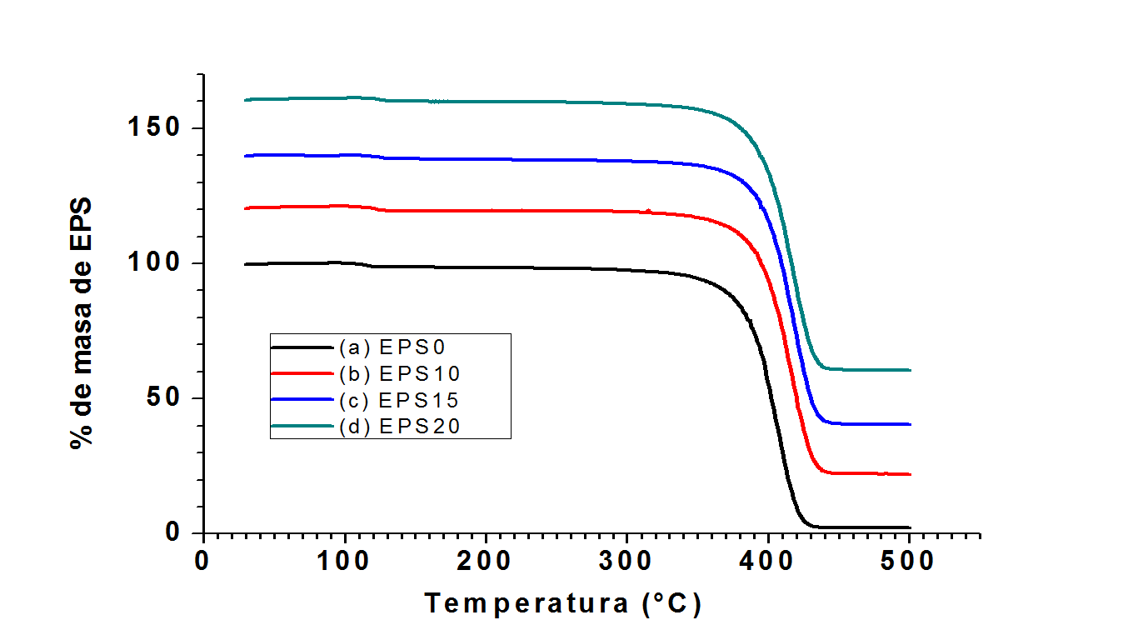
Temperature (°C)
% of EPS mass *

Figure 3. Thermal Gravimetric Analysis (a) EPS₀; (b) EPS₁₀; (c) EPS₁₅; (d) EPS_{20.} Source: Authors
*The mass percentage data concerning EPS₁₀, EPS₁₅ and EPS₂₀ were intentionally displaced 20, 40, and 60%, respectively, in order to improve the display of the results.

Figure 4. Linear distribution of temperatures in a plate thickness of 0,50m, unsteady state, with inhomogeneous boundary conditions (T(0,0)=0°C and T(0,0.5)=80°C); in a time interval 500, i.e. 2500 minutes (a) EPS₀ with a α = 4,9x10⁻⁹ m²/s. (b) EPS10 with a α=6,2x10⁻⁹m²/s. (c) EPS15 with a α = 4,3x10⁻⁹ m²/s. (d) EPS20 with a α =2,8x10⁻⁹ m²/s. Source: Authors
**The temperature data concerning EPS₁₀, EPS₁₅, and EPS₂₀ were intentionally displaced 10, 20, and 30° C, respectively, in order to improve the display of the results.

