Table 1. Common mathematical formulations for the DPHHC
Location-Allocation (LA)  Hess et al. (1965) | Facility-Location (FL)  Hojati (1996) | Set-Partitioning (SP)  Bennet (2010)
Notation:  $m:$ defined set of district centers  $n:$ set of basic units  $c_{ij}:$ cost of assigning subunit $i$ to district center $j$  $x_{ij}:$ binary variable indicating whether subunit $i$ is assigned to district center $j$  $d_{i}:$ demand of basic unit $i$,  $\overline{a}=\sum_{i}{d_{i}}/m:$ average demand | Notation:  (additional to Hess et al., 1965)  $m:$ set of potential district centers  $n:$ set of basic units  $x_{ij}:$ variable indicating the fraction of subunit $i$ to be assigned to district center $j$  $y_{j}:$ binary variable indicating whether subunit $j$ is selected as a district center | Notation:  $D:$ set of all feasible districts  $γ_{ij}:$ binary parameter indicating 1 if district $j$ includes subunit $i$ and 0 otherwise  $C_{j}$: cost of district $j$  $y_{j}:$ binary variable indicating whether district $j$ is selected
Formulation:  $$Min\sum_{j=1}^{m}{\sum_{i=1}^{n}{c_{ij}x_{ij}}}$$ (1)  Subject to:  $$\sum_{i=1}^{n}{d_{i}x_{ij}}=\overline{a}, ∀j$$ (2)  $$\sum_{j=1}^{m}{x_{ij}}=1, ∀i$$ (3)  $$x_{ij} ∈\{0,1\}$$ (4) | Formulation:  $$Min\sum_{j=1}^{m}{\sum_{i=1}^{n}{c_{ij}x_{ij}}}$$ (5)  Subject to:  $$\sum_{j=1}^{m}{x_{ij}}=1, ∀i$$ (6)  $$\sum_{i=1}^{n}{d_{i}x_{ij}}=\overline{a}y_{j}, ∀j$$ (7)  $$\sum_{j=1}^{n}{y_{j}}=m$$ (8)  $$x_{ij}≤y_{j}, ∀i,j$$ (9)  $$0≤x_{ij}≤1, ∀ i,j$$ (10)  $$y_{j} ∈\{0,1\}$$ (11) | Formulation:  $$Min\sum_{j ∈ D}{C_{j}y_{j}}$$ (12)  Subject to:  $$\sum_{j ∈ D}{γ_{ij} y_{j}}=1, ∀i$$ (13)  $$\sum_{j ∈ D}{y_{j}}=m$$ (14)  $$y_{i} ∈\{0,1\}$$ (15)
Objective  (1) Minimizes the total cost of assigning subunits to district centers | Objective  (5) Minimizes the total cost of assigning subunits to district centers | Objective  (12) Minimizes the total cost of all selected districts
Constraints  (2) Ensure that demand assigned to each district is equal to the average demand  (3) Ensure each subunit is assigned exactly to one district | Constraints  (6) Same as (3)  (7) Same as (2) if a district is open  (8) Ensure $m$ districts are selected  (9) Ensure subunits can only be assigned to selected districts | Constraints  (13) Ensure that each subunit $i$ is included in exactly one district  (14) Ensure that $m$ districts are selected
Source: Presented by the authors based on each referred paper

Table 2. HHC Services offered in Cali, Colombia
Type of Medical Activity  $$a∈A$$ | Type of Medical Staff  $$k∈K$$ | Group | Standard  Service Time $\overline{{st}_{a}}$, [min] | Annual  Demand $\overline{d_{a}}$  [annual visits]
Medicines Supply (MSP) | Auxiliary Nurse (AN) | G1 | 30 | 45.950
Auxiliary Nurse Care (ANC-6) |  |  | 360 | 5.240
Auxiliary Nurse Care (ANC-12) |  |  | 720 | 15.040
Auxiliary Nurse Care (ANC-24) |  |  | 1.440 | 38.360
Nursing Care (NCR) | Nurse (NU) |  | 30 | 12.530
General Practitioner Visit (GPV) | Gn. Practitioner (GP) | G2 | 30 | 6.590
Specialist Home Visit (SHV) | Specialist (SP) |  | 30 | 2.180
Therapies Home Visit (THV) | Therapist (TE) |  | 60 | 176.360
Source: Presented by the authors

Table 3. Results minimizing Travel Workload ($f_{1}$)
m | $f_{1}^{*}$: Travel Workload [hr/year] | Total Workload [hr/year] | Average Workload [hr/year] | $f_{2}$:Workload Deviations [hr/year] | Ratio $T_{T}/V_{T}$
1 | 1.132.067 | 2.230.377 | 2.230.377 | 0 | 103,07%
2 | 435.002 | 1.533.310 | 766.655 | 210.800 | 39,61%
3 | 242.188 | 1.340.498 | 446.833 | 277.036 | 22,05%
4 | 179.018 | 1.277.328 | 319.332 | 79.658 | 16,30%
5 | 129.777 | 1.228.087 | 245.617 | 346.956 | 11,82%
6 | 94.087 | 1.192.397 | 198.733 | 340.506 | 8,57%
7 | 72.868 | 1.171.178 | 167.311 | 231.159 | 6,63%
8 | 55.736 | 1.154.045 | 144.256 | 172.255 | 5,07%
9 | 43.844 | 1.142.154 | 126.906 | 263.710 | 3,99%
10 | 34.324 | 1.132.633 | 113.263 | 199.284 | 3,13%
11 | 27.805 | 1.126.115 | 102.374 | 226.629 | 2,53%
12 | 22.307 | 1.120.617 | 93.385 | 244.243 | 2,03%
Source: Presented by the authors

Table 4. Results minimizing Workload Deviations ($f_{2}$)
m | $f_{2}^{*}$:Workload Deviations [hr/year] | Total Workload [hr/year] | Average Workload [hr/year] | $f_{1}:$Travel Workload [hr/year] | Ratio $T_{T}/V_{T}$
1 | 0 | 2.230.383 | 2.230.383 | 1.132.073 | 103,07%
2 | 11.492 | 1.579.638 | 789.819 | 481.328 | 43,82%
3 | 18.046 | 1.448.363 | 559.545 | 350.053 | 31,87%
4 | 24.600 | 1.317.087 | 329.272 | 218.777 | 19,92%
5 | 30.408 | 1.226.503 | 174.402 | 128.193 | 11,67%
6 | 36.217 | 1.225.637 | 204.273 | 127.327 | 11,59%
7 | 37.083 | 1.226.503 | 175.413 | 128.193 | 11,67%
8 | 37.949 | 1.172.423 | 146.553 | 74.113 | 6,75%
9 | 47.158 | 1.163.543 | 131.010 | 65.233 | 5,94%
10 | 56.367 | 1.154.663 | 115.466 | 56.353 | 5,13%
11 | 80.945 | 1.149.851 | 105.443 | 51.541 | 4,69%
12 | 105.523 | 1.145.040 | 95.420 | 46.730 | 4,25%
Source: Presented by the authors

Table 5. Trade-offs Analysis: Travel Workload ($f_{1}$) and Workload Deviations ($f_{2}$)
$$∝$$  [%] | $f_{1}:$Travel Workload [hr/year] | $f_{2}$:Workload Deviations [hr/year] | Total Workload [hr/year] | Average Workload [hr/year] | Deterioration of $f_{1}^{*}$ | Improvement of $f_{2}$
1 | 55.735 | 172.255 | 1.154.045 | 144.256 | 0,00% | 0,00%
5 | 56.478 | 155.369 | 1.154.788 | 144.348 | 1,33% | 10,87%
10 | 57.400 | 146.450 | 1.155.710 | 144.464 | 2,99% | 17,62%
15 | 57.969 | 99.811 | 1.156.279 | 144.535 | 4,01% | 72,58%
20 | 58.779 | 92.211 | 1.157.089 | 144.636 | 5,46% | 86,80%
25 | 62.303 | 93.706 | 1.160.613 | 145.077 | 11,78% | 83,83%
30 | 63.094 | 74.474 | 1.161.404 | 145.176 | 13,20% | 131,30%
Source: Presented by the authors

Figure 1. Cali, Colombia: Population Distribution
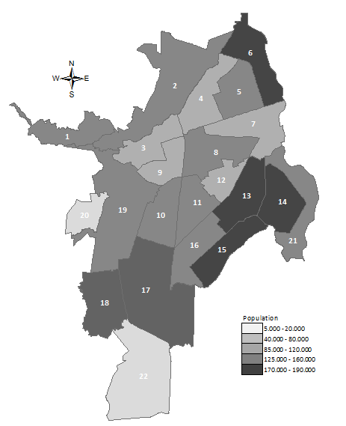
Source: Presented by the authors based on (DAP, 2012)

Figure 2. Optimized values when minimizing Travel Workload ($f_{1}$)
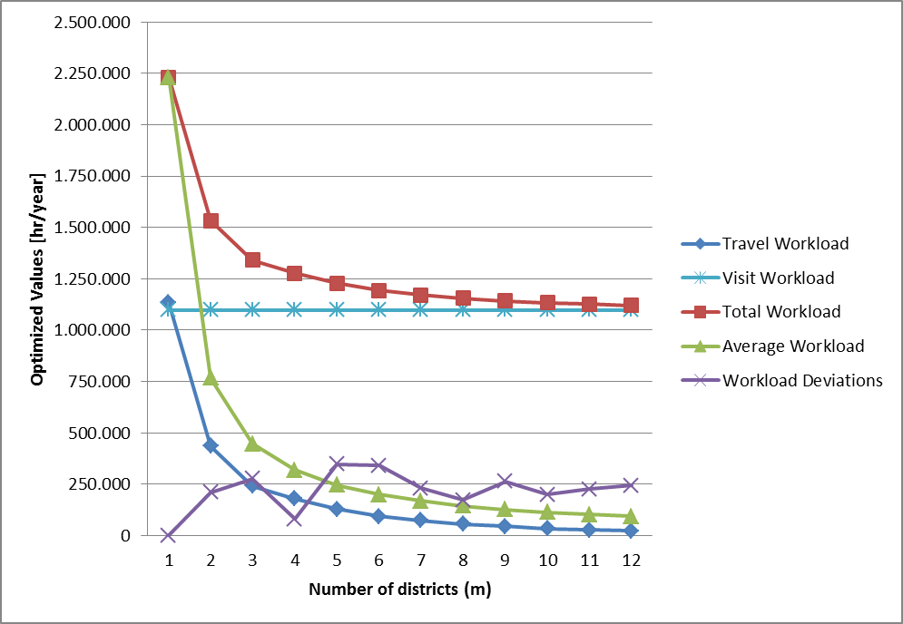
Source: Presented by the authors

Figure 3. Efficient Frontier: Travel Workload ($f_{1}$) and Workload Deviations ($f_{2}$)
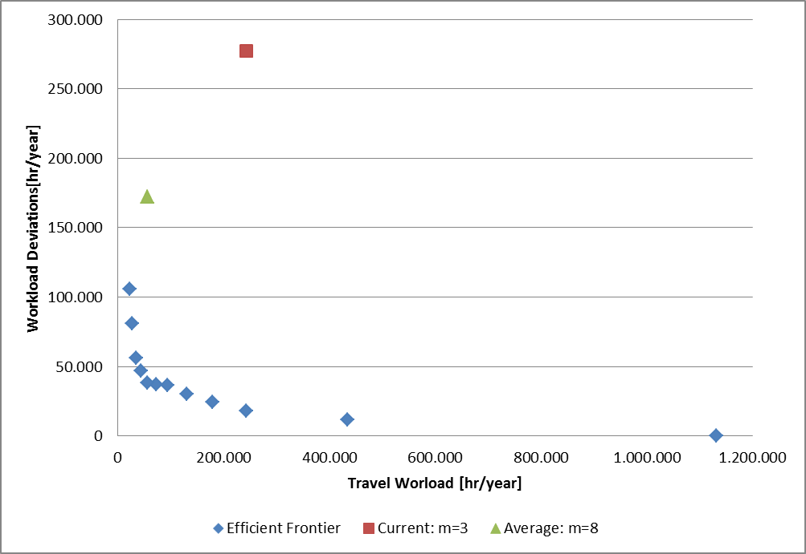
Source: Presented by the authors
Figure 4. Districting Configurations Obtained
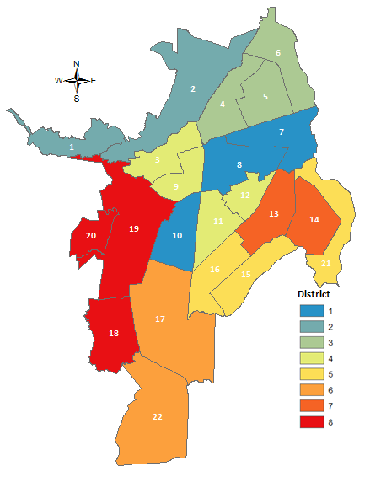  a. Minimizing: Total Travel Workload individually | 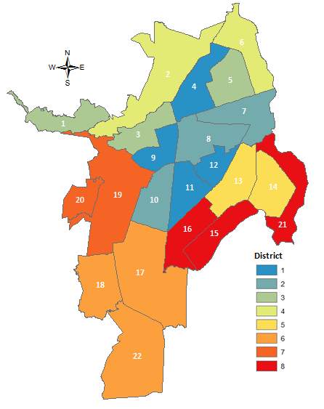  b. Thresholds: Total Travel Workload vs. Workload Deviations ($∝ =20\%$)
Source: Presented by the authors
Figure 5. Trade-offs Analysis: Improvements of Workload Deviations $(f_{2})$ due to Deterioration of Travel Workload ${(f}_{1}^{*})$
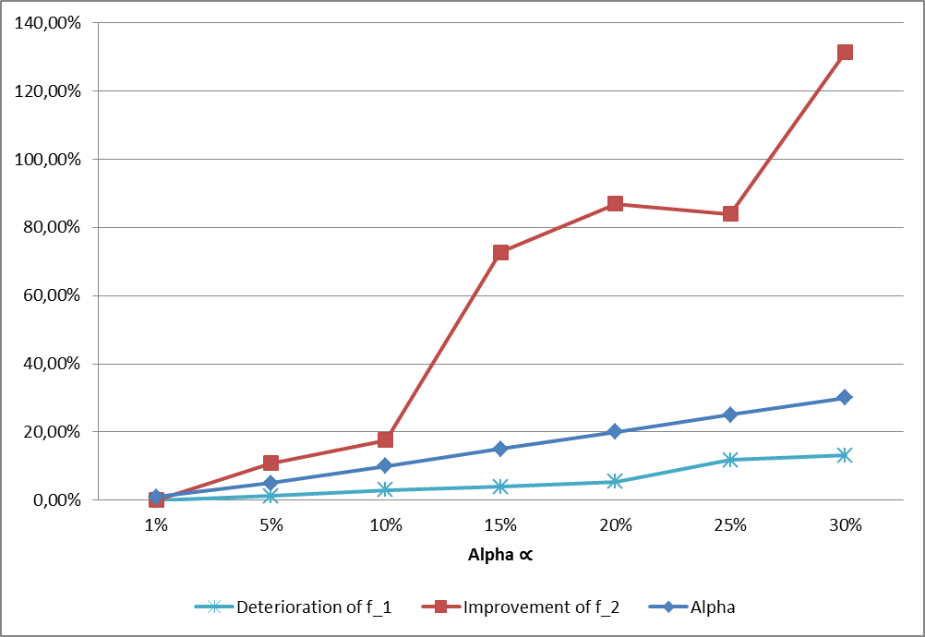
Source: Presented by the authors

