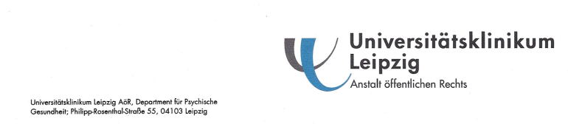

Prof. Wilson López López
Editor Revista Universitas Psicológica Prof. Dr. Thomas Suslow
Facultad de Psicología Department of Psychosomatic Medicine Pontificia Universidad Javeriana University of Leipzig
Bogotá D.C. Semmelweisstr.10, 04103 Leipzig, Germany
Colombia
phone: ++49 341 97 18891
fax: ++49 341 97 18849
Email: thomas.suslow@medizin.uni-leipzig.de

Leipzig, February 11, 2013

RE: Submission of a manuscript for evaluation entitled “Alexithymia and perception of emotional information: A review of experimental psychological findings”

Dear Prof. Lopez,
dear Ladies and Gentlemen,

with this letter we submit a review paper on the perception of emotion stimuli in alexithymia to you (authors: U.S. Donges, A. Kersting & T. Suslow). In our manuscript we review systematically studies reporting experimental psychological findings as a function of the personality trait alexithymia which refers to difficulties in identifying and describing emotions. We take into consideration automatic and controlled processing of external emotional information. My coauthors and I believe that this review can make an original and important contribution to the field of perception and personality. We prepared the manuscript which consists of 27 pages following the publication guidelines of the American Psychological Association.
The paper is not submitted for publication elsewhere and has not been published in part or in full in any other journal. In case our manuscript will be accepted for publication in Universitas Psicologica we will transfer our copyright to your journal. Please find enclosed three hard copies of our manuscript and an electronic copy on a disk.
If you have any questions regarding our manuscript please don’t hesitate to contact me.
Thank you very much for your attention and efforts.
Sincerely Yours

Prof. Dr. Thomas Suslow

