ANEXOS

Tabla 1: ANALISIS DE VARIANZA ANOVA - EXPRESION RANKL AREA TENSION VS AREA CONTROL

One-way ANOVA: RANKL versus Zona
Source DF SS MS F P
Zona 3 3119190 1039730 11.86 0.000
Error 79 6923893 87644
Total 82 10043084
S = 296.0 R-Sq = 31.06% R-Sq(adj) = 28.44%
Individual 95% CIs For Mean Based on
Pooled StDev
Level N Mean StDev -------+---------+---------+---------+--
Control 16 7.7 17.3 (------*-------)
Tensión 21 41.7 132.0 (-----*------)
-------+---------+---------+---------+--
0 200 400 600
Pooled StDev = 296.0

TABLA 2: TEST DE KRUSKALL-WALLIS, EXPRESION RANKL AREA TENSION VS AREA CONTROL

Kruskal-Wallis Test: RANKL versus Zona
Kruskal-Wallis Test on RANKL
Zona N Median Ave Rank Z
Control 16 0.000000000 24.3 -3.27
Tensión 21 0.000000000 27.0 -3.30
Overall 83 42.0
H = 30.47 DF = 3 P = 0.000
H = 32.52 DF = 3 P = 0.000 (adjusted for ties)

Tabla 3: ANALISIS DE VARIANZA ANOVA - EXPRESION OPG AREA TENSION VS AREA CONTROL

One-way ANOVA: OPG versus Zona
Source DF SS MS F P
Zona 3 126 42 0.14 0.939
Error 79 24494 310
Total 82 24620
S = 17.61 R-Sq = 0.51% R-Sq(adj) = 0.00%
Individual 95% CIs For Mean Based on Pooled StDev
Level N Mean StDev +---------+---------+---------+---------
Control 16 133.70 18.42 (----------------*-----------------)
Tensión 21 136.87 16.44 (---------------*--------------)
+---------+---------+---------+---------
125.0 130.0 135.0 140.0
Pooled StDev = 17.61

TABLA 4: TEST DE KRUSKALL-WALLIS, EXPRESION OPG AREA TENSION VS AREA CONTROL

Kruskal-Wallis Test: OPG versus Zona
Kruskal-Wallis Test on OPG
Zona N Median Ave Rank Z
Control 16 140.4 39.4 -0.47
Tensión 21 139.3 41.0 -0.21
Overall 83 42.0
H = 0.40 DF = 3 P = 0.941
H = 0.40 DF = 3 P = 0.941 (adjusted for ties)

FIGURA 1 : EXPRESION RANKL AREA TENSION VS AREA CONTROL

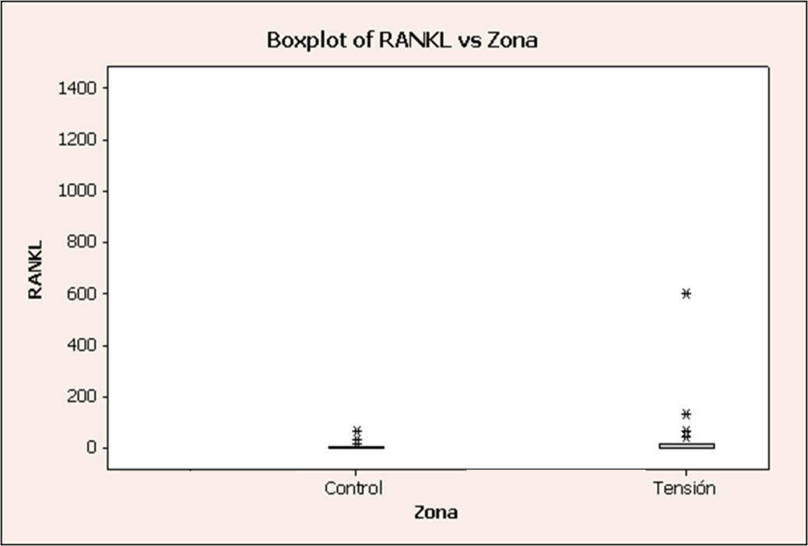

FIGURA 2: EXPRESION RANKL SEGÚN MAGNITUD DE FUERZA E INTERVALO DE TIEMPO

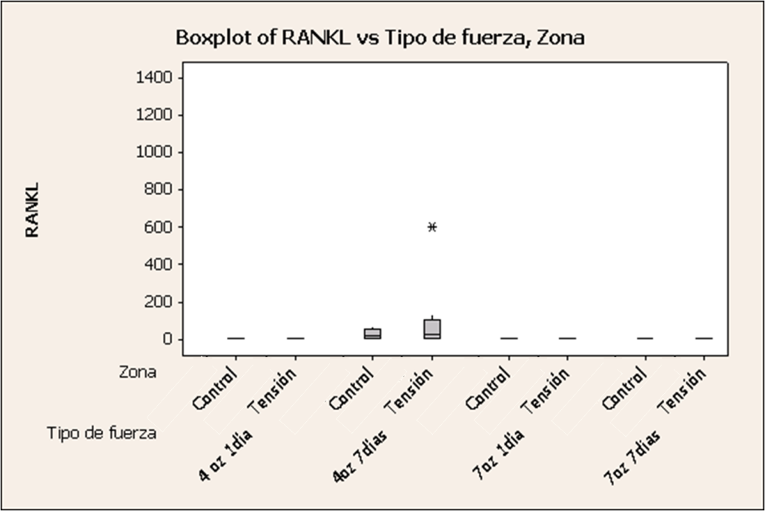

FIGURA 3: EXPRESION OPG AREA TENSION VS AREA CONTROL

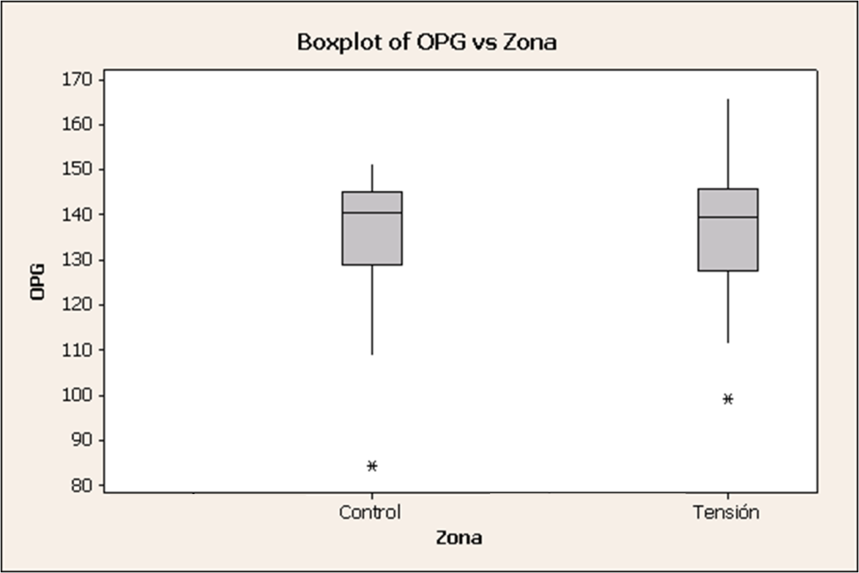

FIGURA 4: EXPRESION OPG SEGÚN MAGNITUD DE FUERZA E INTERVALO DE TIEMPO

