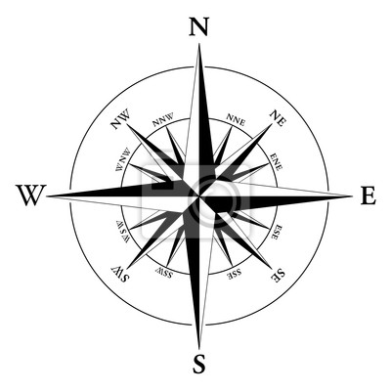
500
Kilometers
25
Kilometers
RISARALDA
10
Kilometers
OTUN RIVER BASIN
COLOMBIA
1
Kilometers
!
(
!
(
!
(
!
(
!
(
!
(
!
(
!
(
!
(
!
(
SANTUARIO DE FLORA Y FAUNA OTUN QUIMBAYA
OTUN_CAMERAS_09-11
Otún River
VEGETATION COVER TYPES
Regenerating vegetation
(RvFa-RvCo)
Old growth Secondary Forest (SF)
Young growth Secondary Forest (SF)
Urapan Forest (UF)
Colombian Oak Forest (OF)
Main Road River
Fig. 1. Location of camera traps within the Wildlife Sanctuary Otún Quimbaya, Risaralda, Colombia. Sources: SIG CIEBREG, ArcGIS 9.3, Datum D_MAGNA.

