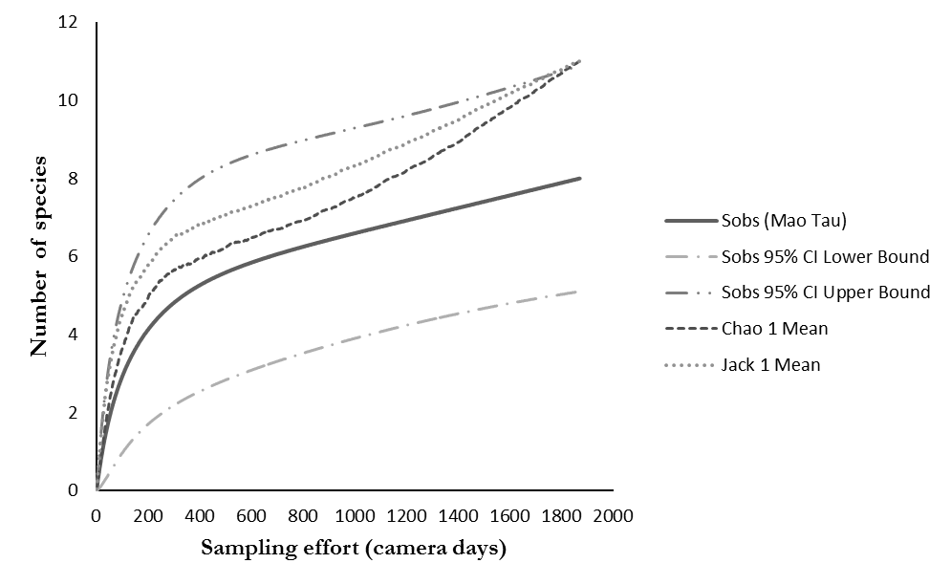

Fig. 2. Wild mammal species accumulation curve, for a sampling effort of 2066 camera days, between the second semester of 2009 and first semester 2011, in the SFFOQ. Number of species observed (Sobs Mao Tau), expected species, upper and lower bounds (CI Upper Bound and CI Lower Bound) and non-parametric estimators of expected species richness (Chao 1 Mean and Jack 1 Mean).

