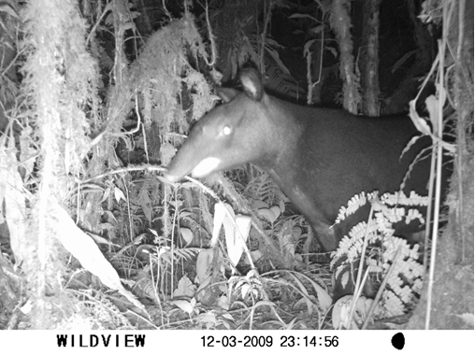

Fig. 3. Photograph for the positive identification of Tapirus pinchaque inside vegetation covers of SFFOQ.

