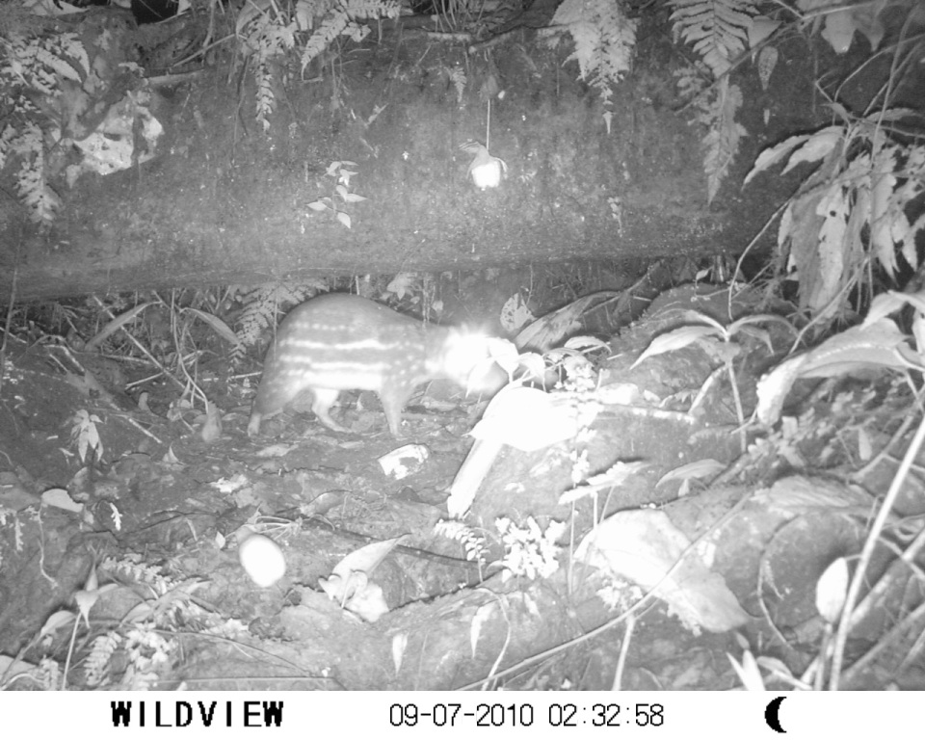

Fig. 4. Photograph for positive identification of Cuniculus paca, based on the stripe pattern on the animal’s flank. Description based in Bonilla-Morales et al. (2013).

