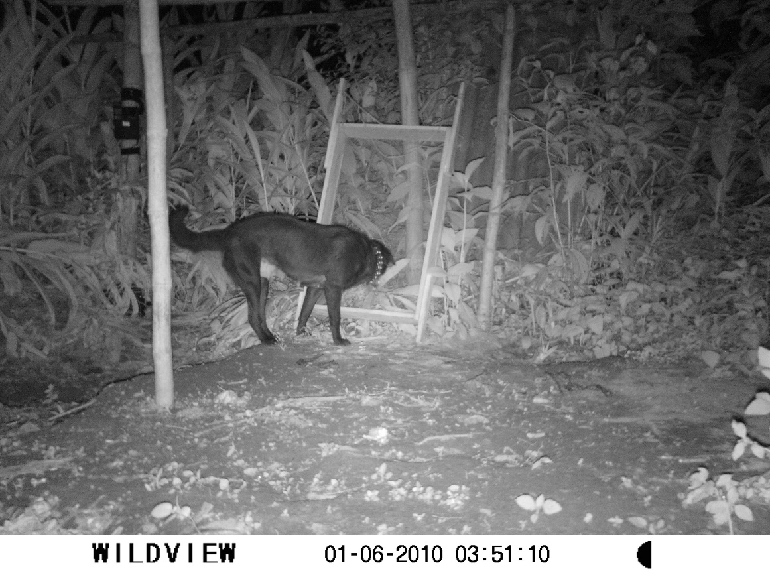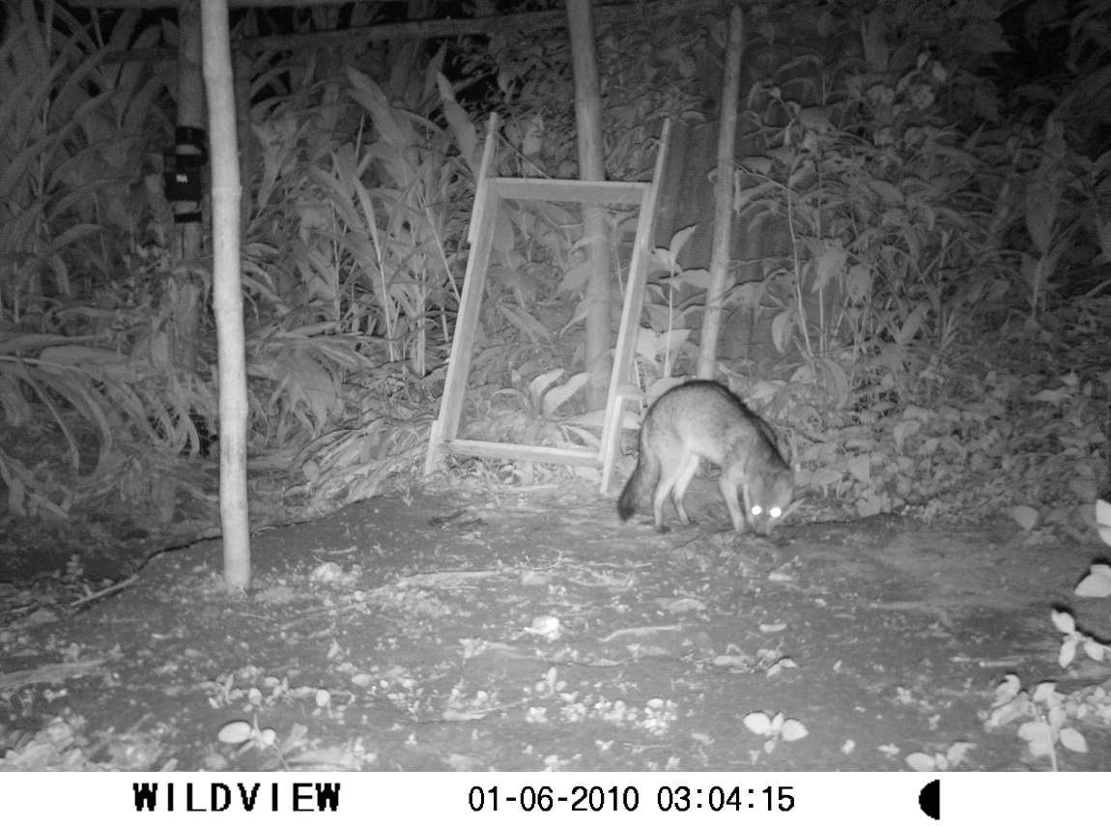
A
B
Fig. 5. Photographs indicating the same cover uses, in the same date but in a different time, by the species A) Canis lupus familiaris and B) Cerdocyon thous.

