**Table 1:** Fatty acid composition of Jatropha oil

|  |  |
| --- | --- |
| **Fatty acid** | **Composition (wt %)** |
| Oleic (C18:1) | 44.9 |
| Linoleic (C18:2) | 34.1 |
| Palmitic (C16:0) | 12.2 |
| Stearic (C18:0) | 7.33 |
| Linolenic (C18:3) | 0.17 |

**Table 2:** Chemical composition of different NiMo/AC catalysts

|  |  |  |  |  |  |  |
| --- | --- | --- | --- | --- | --- | --- |
| **Catalysts** | **Nominal (wt.%)** | | | **Chemical analysis (wt.%)** | | |
| **Ni** | **Mo** | **Ni:Mo** | **Ni** | **Mo** | **Ni:Mo** |
| **Commercial** | 4.2b | 10.9b | 0.38 | - | - | - |
| **Ni3Mo10/AC** | 3 | 10 | 0.30 | 4.5 | 12.4 | 0.36 |
| **Ni3Mo15/AC** | 3 | 15 | 0.20 | 4.4 | 17.4 | 0.25 |
| **Ni5Mo10/AC** | 5 | 10 | 0.50 | 6.9 | 12.0 | 0.57 |
| **Ni5Mo15/AC** | 5 | 15 | 0.33 | 6.1 | 16.0 | 0.38 |

*aOn dry ash free basis bObtained by x-ray fluorescence*

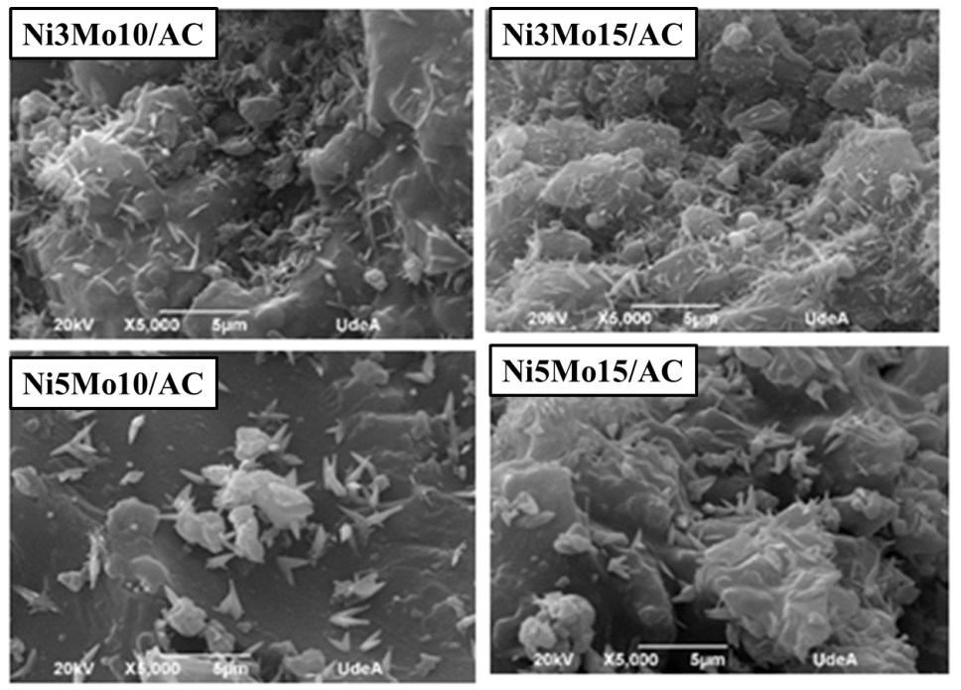

**Figure 1:** SEM micrographs of variable concentration of NiMo/AC catalysts

C:\Users\JuanT\Desktop\IR.tif

**Figure 2:** FT-IR spectra of Jatropha oil and products.

C:\Users\JuanT\Desktop\products.tif

**Figure 3: S**electivity of catalysts toward various fractions of hydrocarbons obtained in the HDO process of Jatropha oil.

C:\Users\JuanT\Desktop\gas.tif

**Figure 4:** Composition of the gaseous products after HDO of Jatropha oil for the different catalysts (H2 balance)

C:\Users\JuanT\Desktop\rel.tif

**Figure 5:** Effect of Ni and Mo concentration (wt. %) in the selectivity toward C17 and C18 hydrocarbons