Title: Study of body fluid samples using flow cytometry: 6 years of experience at the University Hospital San Ignacio-Pontificia Universidad Javeriana Bogota-Colombia.
Authors: Alba Campos^{1**}, Laura Trujillo^{2**}, Derly López², Lina Beltrán², Eliana Arias¹, Graciela Vélez¹, Antonia Infante¹, Iliana De Los Reyes^{3,7}, Martha Vizcaíno^{3,7}, Paula Carolina Guzmán^{3,7}, Maria Victoria Herrera³, Julio Solano³, Dario Londoño⁴, Alejandra Cañas⁴, Felipe Pretelt⁵, Juan Carlos Pérez⁶, Claudia Cardozo¹, Susana Fiorentino⁸ y Sandra Quijano⁸.
Institutional affiliation:
- Area de Citometría de Flujo Laboratorio Clínico Hospital Universitario San Ignacio, Bogotá, Colombia.
- Carrera de Bacteriología Facultad de Ciencias Pontificia Universidad Javeriana, Bogotá, Colombia.
- Unidad de Hematología y Oncología Hospital Universitario San Ignacio-Pontificia Universidad Javeriana, Bogotá, Colombia.
- Unidad de Neumología Hospital Universitario San Ignacio, Pontificia Universidad Javeriana, Bogotá, Colombia.
- Unidad de Neurología Clínica Hospital Universitario San Ignacio, Bogotá, Colombia.
- Unidad de Neuropediatría Hospital Universitario San Ignacio, Bogotá, Colombia.
- Departamento de Pediatría Facultad de Medicina Pontificia Universidad Javeriana, Bogotá, Colombia.
- Grupo de Inmunobiología y Biología Celular Departamento de Microbiología Facultad de Ciencias Pontificia Universidad Javeriana, Bogotá, Colombia.
**: The first two authors are considered first authors for their contributions to the work.
Corresponding author: Sandra Quijano, Grupo de Inmunobiología y Biología Celular, Departamento de Microbiología. Pontificia Universidad Javeriana Bogotá-Colombia, Cra. 7 N° 43-82, Edificio 50, Oficina 307; Phone: +57-1-3208320, ext: 4181; E-mail: *squijano@javeriana.edu.co
Short running title: Study of body fluids using flow cytometry.
Key words: body fluids, flow cytometry, immunophenotype.
Manuscript type: Original article.

Abstract:
In 2008, at the Pontificia Universidad Javeriana and later at the Hospital Universitario San Ignacio, flow cytometry (FCM) was implemented to examine special samples other than bone marrow and peripheral blood for the diagnosis and monitoring of patients with hematological malignancies and solid tumors. In this study, we describe the main findings of the evaluation of special samples over a period of six years. In all, 1070 samples of body fluids from patients with benign and malignant diseases were examined by FCM. These samples were stabilized with TransFixTM and stained with six-color immunophenotyping panels. The samples included cerebrospinal fluid, bronchoalveolar lavage, pleural fluid, pericardial fluid and ascites fluid from patients with acute and chronic leukemia, myelodysplastic syndromes, lymphomas, myeloma, autoimmune diseases, immunodeficiencies and solid tumors, among others. Flow cytometry provided important information for the classification and detection of minimal numbers of tumor cells in leukemia and lymphoma cases.
This work represents the first national report that describes the implementation of FCM in special samples for evaluation at the time of diagnosis and for the clinical monitoring of patients with malignant and benign pathologies.

Introduction
Currently, FCM represents a diagnostic tool with high sensitivity and specificity that is recommended for routine clinical diagnosis, immunological classification and post-treatment follow-up of patients with various types of diseases including hematological malignancies, solid tumors, infectious diseases and immune deficiency (1-3). Analysis by FCM can be performed on different types of biological samples such as bone marrow (BM), peripheral blood (PB), stem cell grafts, umbilical cord tissue biopsies and body fluids, among others (1). Samples of body fluids are considered special due to different cell viability, small sample volumes and variability in their contents and cell concentrations (4-5). Less than six hours after they are obtained, these samples demonstrate decreased cell viability and low quality, which may present challenges for an analysis by FCM (4-7).
For this reason, in the last decade, the use of commercially available cell stabilization solutions has been recommended; these solutions can preserve samples of PB and cerebrospinal fluid (CSF) over time periods longer than one week after collection (4, 8-9). This stabilization preserves the cellularity and integrity of both cell surface and intracellular antigens (9).
The flow cytometry service of the Faculty of Sciences of the Pontificia Universidad Javeriana began to implement FCM in the study of stabilized body fluids in 2008. These samples were fixed with TransFixTM (Cytomark, Buckingham, UK) (2, 4-5) at the time of collection. Then, the cytometry service was transferred to the Hospital Universitario San Ignacio, where FCM is currently performed; today, special samples from pediatric and adult patients with various diseases that require correct classification and/or staging are evaluated there.
In our experience at our own institution, FCM has contributed significantly to the detection of tumor populations that have infiltrated various tissues such as the central nervous system, which is a clinical complication associated with increased aggressiveness and poor prognosis in patients with acute leukemia and lymphoma (2, 4-5, 7, 10). Additionally, it is important to note that compared with morphological studies, FCM detects very low numbers of tumor cell populations (<0.01%), which cannot be detected by morphological techniques because of lower sensitivity; these tumor cells may even be detected by FCM before the onset of clinical symptoms (4, 10-12).
Given that, as of now, in Colombia, no documented results have been published on the implementation of FCM in the study of stabilized body fluids, in the present study, we report the main findings of the evaluation of body fluids by FCM over a period of six years at the Pontificia Universidad Javeriana and Hospital Universitario San Ignacio. These include technical recommendations for both the processing and analysis of these samples in the pre-analytical and analytical phases, absolute and relative cell counts of normal and tumor cell populations, sample volumes, types of diseases and the clinical time point of the evaluation.
The generalization of this experience will be useful for other cytometry services in our country in order to better apply this tool in clinical practice.

Materials and Methods
Here, we describe all special fluid samples that have been processed and analyzed from June 2008 until the month of June 2014 at Pontificia Universidad Javeriana and Hospital Universitario San Ignacio. Information collected includes sex, age, diagnosis, type of sample, volume, cellularity, tumor infiltration rate and reason for the study (diagnosis, monitoring post-chemotherapy, relapse or progression).

Nonparametric statistics were used to analyze the results. Median values, the mean and the range were calculated for all variables using the SPSS software program (SPSS 19, Chicago, IL, USA). To establish the statistical significance of differences observed among different groups, the Wilcoxon and the Mann–Whitney U tests were used. P-values that were <0.05* and p<0.01** were considered statistically significant.

Protocol used for processing, labeling, acquisition and analysis of special samples (body fluids) by FCM

In the Colombian Consensus of FCM, which was established in 2008 (Saavedra C et al 2010), it was recommended that samples of body fluids (specifically CSF) be stabilized in tubes with the commercially available fixative agent TransFixTM (Cytomark, Buckingham, UK) from the time of collection (Barnett D. Patent WO 95/01796, 1995); this method has been validated in previous studies (2, 4-5, 13). TransFixTM is a cellular stabilization reagent that contains a buffer, an aliphatic aldehyde (AA) that fixes cells by the cross-linking of amino-acid residues, and heavy metal salts, which reduce excessive auto fluorescence caused by AA; this fixative also preserves the samples for longer periods (up to 10 days) (4, 13). In the pre-analytical phase, TransfixTM is immediately added by the attending clinician to the samples at the time of collection. Once stabilized, the samples are transported to the laboratory at 4°C. It is recommended that specimens be incubated with TransFixTM for at least 18 hours prior to processing because this leads to higher leukocyte counts and improves the detection of tumor cells in these samples (13).
The detailed procedure for sample processing is as follows:

Measure the total volume of the sample received and document the measurements.

Add 2 ml of phosphate buffered saline (PBS) + 0.5% bovine serum albumin (BSA).

Centrifuge at room temperature for 10 min at 500 x g.

Remove supernatant with a Pasteur pipette and resuspend the cell pellet in 300-µl PBS + 0.5% BSA.

Transfer 100 µl of the sample to another tube and store the remaining sample volume at 4°C.

According to the suspected clinical diagnosis, stain the samples with the appropriate antibody panel (Table 1).

Add the appropriate volume of each monoclonal antibody according to the chosen immunophenotypic panel based on the clinical question.

Incubate 15 min at room temperature in the dark.

Add 2 ml of FACS lysing solution (Becton Dickinson Biosciences) diluted 1:10 and incubate for 10 min at room temperature.

Centrifuge at room temperature for 10 min at 500 x g.

Remove supernatant with a Pasteur pipette and resuspend the cell pellet in 300-µl PBS + 0.5% BSA.

Add premixed count beads to each stained sample just prior to FCM measurement in order to calculate absolute cell counts.

Mix and acquire the entire sample volume in the flow cytometer. Note: Prior to acquisition, it is necessary to clean the cytometer with a washing solution for at least 5 minutes to avoid contamination of the sample with others that have been previously acquired.

Analyze the sample using the appropriate software (e.g., INFINICYTTM Cytognos).

To calculate the absolute number of each cell subpopulation, apply the following formula (4-5, 14):
# events in cell subset gate x # beads added per tubeª x correction factor^{c} = Cells/µl
# events in beads gate ª volume of sample (µl)^{b}
- The total number of beads added to the tube is calculated as follows: volume of beads added to the tube (e.g., 20 µl) x bead concentration (beads/µl) (these data are provided by the manufacturer).

- Total volume of the sample at the time of collection (µl).

- The correction factor is equal to the initial volume of the sample (e.g., 5000 µl) divided by the volume of the concentrated sample used for staining in each tube (e.g., 100 µl). Thus, in the protocol described, the correction factor is: 5000 µl/100 µl = 50.
- In the analysis, classify clusters of more than 25 events fulfilling the above criteria as positive, clusters of 10 to 25 events as suspicious, and clusters of fewer than 10 events as negative (5).
- If after the analysis no tumor infiltration is detected, the process should be repeated with the remaining sample volume (200 µl) and with the same combination of antibodies in order to increase assay sensitivity. Conversely, if tumor infiltration is detected, and depending on the total number of cells/µl, perform an additional panel to characterize the immunophenotype of the cell population.
- Generate the analysis report.
To perform the simultaneous staining of membrane and intracellular antigens, a fixation and permeabilization kit (IntraStain-Dako) was used. First, the membrane antigens (step 7) were stained, and then the sample was incubated with 100 µl of fixative solution (Reagent A). Next, 100 µl of permeabilization solution (Reagent B) was added to the antibodies against the intracellular antigens. In this last step, incubation was performed for 30 minutes at room temperature in the dark, followed by washes with PBS + 0.5% albumin (step 10 onwards).

Results
In all, 1070 special samples from 653 males (61%) and 417 females (39%) were studied retrospectively in the cytometry service of the Pontificia Universidad Javeriana and Hospital Universitario San Ignacio, between June 2008 and June 2014. The mean age of the patients at the time of analysis was 37 years (range: 3 months old-88 years).
Most samples consisted of CSF (n = 932; 87.1% of cases), while pleural fluid samples (n = 95; 8.9%), bronchoalveolar lavage (n = 24; 2.2%), pericardial fluid (n = 8; 0.7%), peritoneal fluid (n = 7, 0.7%), ascites (n = 3, 0.3%) and synovial fluid (n = 1; 0.1%) represented fewer samples (Figure 1). Sample volumes were variable and ranged from 0.2 ml (in CSF samples) to 60 ml (in samples of pleural fluids) (Figure 2). All samples were stabilized with TransFix™ (Cytomark, Buckingham, UK) at the time of collection.
According to the final diagnosis, most cases were acute leukemia (n= 606: B cell acute lymphoblastic leukemia, 495; T cell acute lymphoblastic leukemia, 59, acute myeloblastic leukemia, 23; biphenotypic acute leukemia, 6; and biclonal acute leukemia, 3). Other cases were Non-Hodgkin Lymphomas (NHL) (n= 317: B-NHL, 282; and T-NHL, 35), Hodgkin lymphoma (HL) (n= 8), chronic myeloid leukemia (CML) (n=12), myelodysplastic syndrome (MDS) (n= 5), multiple myeloma (MM) (n= 5), and solid tumors (ST) (n= 21). The remaining samples (n= 96) included patients with neurological symptoms, patients infected with human immunodeficiency virus (HIV+), and patients with autoimmune diseases, infections, and migraine, among other conditions. (Figure 3). In all, 347 cases were analyzed at diagnosis (32%), 682 were analyzed at clinical follow-up (64%) and 41 were analyzed at relapse (4%).

Analysis of samples of cerebrospinal fluid (CSF)

The total number of CSF samples analyzed was 932 and the pathological condition most often tested was infiltration by B cell acute lymphoblastic leukemia (B-ALL) (54% of cases), followed by B-NHL (26%) (Figure 4A). Some cases that were diagnosed as meningoencephalitis, autoimmune diseases, infectious diseases or solid tumors were included as "other" and represented 6% of the total CSF samples (63 samples).
Of all the samples tested, 19% demonstrated tumor infiltration, while the remaining 81% were tumor cell-free (Figure 4B). In patients with positive tumor infiltration, the CSF samples showed a higher absolute number of total cells/µl including T lymphocytes, monocytes and neutrophils compared with CSF samples that were negative for tumor infiltration (Table 2). Notably, FCM was able to detect a minimum number of tumor cells/µl (from 0.01/µl). Examples of representative CSF analyses are shown in Figures 5-7.

Analysis of pleural fluid samples

In all, 95 samples of pleural fluid were assessed for tumor infiltration by B-NHL (56%), followed by cases that were classified as "other," which included infectious diseases, solid tumors, cytopenias, HIV+ cases and pleural effusions. These cases represented 21% of the total (Figure 4C). After an analysis of these cases, it was found that 48 (51%) were infiltrated by tumor cells, while the remaining 47 cases (49%) were negative for tumor infiltration (Figure 4D). In samples with tumor infiltration, FCM detected a minimum of 0.1 tumor cells/µl. Pleural fluids with tumor infiltration showed a significantly higher absolute number of total cells compared with cases without tumor infiltration. In these samples, varying numbers of neutrophils, monocytes, macrophages, T lymphocytes, B lymphocytes, NK cells, plasma cells, dendritic cells and eosinophils (Table 2) were also detected. Examples of pleural fluid analyses both with and without tumor infiltration are shown in Figures 8 and 9.

Analysis of bronchoalveolar lavage (BAL)

In all, 24 samples of BAL were studied in order to detect infiltration by B-NHL (46% of cases) and B-ALL (17% of cases). Seventeen percent of cases that were classified as "other" included samples from patients with sarcoidosis and lymphadenopathy (Figure 4E). After analysis, tumor infiltration was detected in 21% of the samples (Figure 4F). In positive cases, FCM detected a minimum of 0.1 tumor cells/µl.
In these samples, varying numbers of neutrophils, monocytes and macrophages, T lymphocytes, B lymphocytes, NK cells, plasma cells, dendritic cells and eosinophils were also found.

Analysis of other special samples

Pericardial fluid: Eight samples of pericardial fluid were analyzed to assess B-NHL at diagnosis (n = 6), a solid tumor and one case of SLE. All samples were negative for tumor infiltration, and T lymphocytes and monocytes were detected in 100% of the samples; neutrophils (7/8 cases), B lymphocytes (6/8 cases), NK cells (5/8 cases) and plasma cells (4/8 cases) were also detected. The average total cell number was 304/µl (range: 4.5 to 762/µl).

Peritoneal fluid: Seven samples of peritoneal fluid were analyzed in patients with multiple myeloma (n = 2), B-NHL (n = 2), carcinoma (n = 1) and anemia (n = 1); of these, only one case of myeloma was positive for tumor infiltration. An analysis of cellularity showed that T lymphocytes were detected in 100% of patient samples, while NK cells and monocytes were detected in 6/7 cases, B lymphocytes and neutrophils were detected in 5/7 and eosinophils and macrophages were detected in 1/7 cases. The average number of cells detected was 2017/µl with a range of 0.2 to 10.780 cells/µl. The myeloma sample with tumor infiltration had 2811 pathological plasma cells/µl, which represented 92% of the total cellularity.
Synovial fluid: One sample was analyzed for the study of MDS during the clinical monitoring of the disease. This sample had 2.6 myeloid blasts/µl, which was equivalent to 7.6% of the total cellularity. T and B lymphocytes and monocytes were also detected. The total cell number was 34 cells/µl.
Ascites: Three samples of ascitic fluid were analyzed, two for the study of B-NHL infiltration and the other for the study of an infectious process. The two cases of B-NHL were negative for tumor infiltration. In 100% of the samples, T lymphocytes, monocytes, B lymphocytes, NK cells and neutrophils were detected, while plasma cells were detected in two samples. The average total number of cells was 1680/µl with a range of 917 to 2659/µl.

Discussion
In recent years, one diagnostic tool that has become very important in clinical practice is FCM, which provides higher sensitivity and speed and allows for the simultaneous analysis of multiple features, compared with other cell analytical techniques. Currently, antibody panels with 8-10 types of fluorescence are used, which give information on cell lineage, maturation stages, aberrant phenotypes and absolute and relative numbers of normal and tumor cells (1-2, 6).
Many advantages have been reported for FCM in the study of various types of biological samples such as BM, PB and special samples such as tissue biopsies and body fluids (pleural fluid, pericardial fluid, and CSF, among others, have been reported) and in more recent studies by the European Consortium EuroFlow. One advantage is the assessment of vitreous samples for the study of tumor infiltration by intraocular lymphomas and central nervous system lymphomas (1-2, 6). Therefore, it is vital to ensure the quality of the samples in the pre-analytical phase in order to maintain cell viability and the integrity of cellular antigens (6). Some samples evaluated by flow cytometry must be processed within 24 hours (especially BM and PB), but other samples such as body fluids and biopsies may sustain further damage over time; for example, percentages of cell death may rise above 80% between 30 minutes to 6 hours after the sample was obtained (2, 6, 13).
In order to obtain higher quality samples from the pre-analytical phase, the use of commercially available stabilizing solutions has been implemented within the last decade. Examples of these include TransFixTM (Cytomark, Buckingham, UK) and Cyto-Chex BCT (Streck, Omaha, NE, USA), which have both been validated for clinical use (2, 4, 13, 15- 18). Different studies have reported that PB samples treated with these stabilizers and evaluated at different times post-incubation display increased cell viability and maintenance of cell structures, which provides more reliable results that directly reflect the actual condition of the patient (15 -17, 19-20).
Some studies by different groups have focused on the evaluation of the effect of TransFixTM as a stabilizer and have reported various technical indications for its use (Table 3) (21). One of the most important applications of TransFixTM is for the stability of absolute CD4+ T cell counts (important for monitoring HIV+ patients) and in commercial PB preparations used in programs of quality assurance for immunophenotyping of T cell subpopulations. These studies have reported that these counts are stable at various storage temperatures (4°C and 25°C) and for up to 10 days of treatment compared with fresh unstabilized samples (17, 20). However, TransFixTM treatment causes changes in forward scatter and side scatter parameters within 24-48 hours of treatment, as is evidenced mainly in neutrophils and monocytes after 10 days of storage at different incubation temperatures (17, 22).
Comparative studies of the expression of different antigenic markers in leukocyte populations between samples with and without TransFixTM are contradictory. Some studies have shown that PB samples without TransFixTM lose expression of antigens over time. This is a phenomenon that is also correlated with the presence of apoptotic cells as evaluated by propidium iodide staining (22) and that results in a decrease in absolute counts of leucocyte populations (13). On the contrary, the expression of CD3, CD4, CD38, CD123 and CD45 in lymphocytes of patients with primary and secondary immunodeficiencies, leukemias, lymphomas and inflammatory diseases, is stable after incubation with TransfixTM, while CD45 expression decreases significantly in monocytes from day 0 to day 4 of incubation at 4°C (17, 22).
Another parameter evaluated by Canonico B et al in 2010 was the effect of dilution of the sample with TransFixTM (1/5 and 1/10 dilutions) in the expression of CD45 in granulocytes and lymphocytes; they showed that the expression of this molecule is altered by dilutional effects.
An evaluation of cell morphology in PB samples by transmission electron microscopy (TEM) showed that after ten days of storage in TransFixTM and after incubation of samples at different temperatures (4ºC, 25ºC and 37ºC), lymphocytes retain their morphology better compared with other cell types (22).
Other studies have reported the use of TransFixTM in the study and monitoring of infiltration of the central nervous system in patients with aggressive lymphomas and acute leukemias. In these studies, TransFixTM may enhance the detection of hematological malignancies in CSF by preventing cellular loss after 10 days of storage (2, 4, 7, 10, 12-13, 23).
Although the clinical application of TransFixTM in flow cytometry has already been reported in various studies, no consensus has been reached on its implementation in clinical practice, and other studies to evaluate its use in samples other than PB and CSF have not been conducted (24-25). In the first Colombian Flow Cytometry Consensus in 2008, it was recommended that samples of body fluids be stabilized in case they are not processed by the maximum recommended times (6). It is for this reason that from 2008 onward, all samples of body fluids from patients with different pathologies (both benign and malignant diseases) are collected into tubes containing TransFixTM.
The results of the analysis of 1070 samples, which were evaluated over a period of 6 years, show that the medical community and patients have benefitted significantly from the implementation of this tool for the study of special samples. These samples are of a higher quality and therefore allow a better classification and staging of the disease, which has important implications at the therapeutic level, for clinical monitoring of the disease and for prognosis. We note that most special samples processed and analyzed correspond to CSF from patients who were diagnosed with B-ALL. These samples were obtained during different time points in the disease process and have great applicability to other pathologies including other hematological malignancies, solid tumors and other diseases.
Additionally, in all samples tested it is shown that CMF is a tool of great sensitivity as it can detect minute quantities of tumor cells (at least 0.01 cells/µl in CSF samples and 0.1 cells/µl in other samples evaluated) in cases of samples with tumor infiltration. CMF can also detect small numbers of normal cells in various body fluids with and without tumor infiltration in a wide range of diseases. It is important to note that in these cases, rare normal cell populations, such as dendritic cells in the pleural fluid, were also detected (1).
In cases of autoimmune diseases, immunodeficiency, infectious diseases and inflammatory processes, CMF is useful for the description of the cellularity of these samples as it identifies populations of T lymphocytes, B lymphocytes, NK cells, plasma cells, eosinophils, basophils, and macrophages, among other cell types (1).
This work represents the first report at the national level that describes why TransFixTM should be implemented in pre-analytical CMF studies of all body fluids that are processed in clinical practice and why this can be used in all cytometry laboratories in our country to ensure the quality of the results of our patients.

Acknowledgments: The authors appreciate the financial support provided by
the Pontificia Universidad Javeriana and Hospital Universitario San Ignacio.

Conflict of Interest: The authors declare that no conflicts of interest exist in
relation to this work.

References
- Jaye DL, Bray RA, Gebel HM, Harris W, Waller EK. Translational Applications of Flow Cytometry in Clinical Practice. Journal of Immunology. 2012; 188: 4715–19. doi: 10.4049/​jimmunol.1290017

- Van Dongen JJM, Lhermitte L, Bottcher S, Almeida J, van der Velden VHJ, Flores-Montero J, et al. EuroFlow antibody panels for standardized n-dimensional flow cytometric immunophenotyping of normal, reactive and malignant leukocytes. Leukemia. 2012; 26:1908–75. doi: 10.1038/leu.2012.120

- Subirá D, Simó M, Illán J, Serrano C, Castañón S, Gonzalo R, et al. Diagnostic and prognostic significance of flow cytometry immunophenotyping in patients with leptomeningeal carcinomatosis. Clin Exp Metastasis. 2015; 32: 383-91. doi: 10.1007/s10585-015-9716-3

- Quijano S, López A, Manuel SJ, Panizo C, Deben G, Castilla C, et al. Identification of leptomeningeal disease in aggressive B-cell non-hodgkin’s lymphoma: improved sensitivity of flow cytometry. J Clin Oncol. 2009; 27:1462-69. doi: 10.1200/JCO.2008.17.7089

- Kraan J, Gratama JW, Haioun C, Orfao A, Plonquet A, Porwit A, et al. Flow cytometric immunophenotyping of cerebrospinal fluid. Curr. Protocol. Cytom. 2008; Supplement 45: 6.25.16.25.16. 16 p. doi: 10.1002/0471142956.cy0625s45

- Saavedra C, Quijano S, Romero M, Jaramillo R, Orduz R, Echeverri C, et al. Reporte del Primer Consenso Colombiano de Citometría de Flujo para el estudio de trastornos hematológicos. Biomédica 2010; 30(Supl):11-21. http://dx.doi.org/10.7705/biomedica.v30i0.818

- Ranta S, Nilsson F, Harila-Saari A, Saft L, Tani E, Söderhäll S, et al. Detection of Central Nervous System Involvement in Childhood Acute Lymphoblastic Leukemia by Cytomorphology and Flow Cytometry of the Cerebrospinal Fluid. Pediatr Blood Cancer. 2015; 62: 951-6. doi: 10.1002/pbc.25363.

- de Graaf MT, de Jongste AH, Kraan J, Boonstra JG, Sillevis, Smitt PA, et al. Flow cytometric characterization of cerebrospinal fluid cells. Cytometry B Clin Cytom. 2011; 80(5):271-81. doi: 10.1002/cyto.b.20603.

- Davis C, Wu X, Li W, Fan H, Reddy M. Stability of immunophenotypic markers in fixed peripheral blood for extended analysis using flow cytometry. J Immunol Methods. 2011; 363:158-165. doi: 10.1016/j.jim.2010.09.029.
- Del Principe M, Buccisano F, Cefalo M, Maurillo L, Di Caprio L, Di Piazza F, et al. High sensitivity of flow cytometry improves detection of occult leptomeningeal disease in acute lymphoblastic leukemia and lymphoblastic lymphoma. Ann Hematol. 2014; 93:1509–13. doi: 10.1007/s00277-014-2080-6.

Bromberg JE, Breems DA, Kraan J, Bikker G, van der Holt B, Smitt PS, et al. CSF flow cytometry greatly improves diagnostic accuracy in CNS hematologic malignancies. Neurology. 2007; 68:1674-9.

- Ahluwalia MS, Wallace P K, Peereboom D M. Flow cytometry as a diagnostic tool in lymphomatous or leukemic meningitis. Cancer. 2012; 118:1747-53. doi: 10.1002/cncr.26335.

- de Jongste AH, Kraan J, van den Broek PD, Brooimans RA, Bromberg JE, van Montfort KA, et al. Use of TransFix™ cerebrospinal fluid storage tubes prevents cellular loss and enhances flow cytometric detection of malignant hematological cells after 18 hours of storage. Cytometry B Clin Cytom. 2014; 86:272-9. doi: 10.1002/cyto.b.21097

- Roa D, Fiorentino S, Rodríguez V, Campos A, Infante A, Cardozo C, et al. Análisis inmunofenotípico de muestras normales de médula ósea: aplicaciones en el control de calidad en los laboratorios de citometría. Universitas Scientiarum. 2010; 15: 206-23. http://www.scielo.org.co/scielo.php?script=sci_arttext&pid=S0122-74832010000300003

- Saxton JM, Pockley AG. Effect of ex vivo storage on human peripheral blood neutrophil expression of CD11b and the stabilizing effects of Cyto-Chex. J Immunol Methods 1998; 214:11-17.

- Warrino DE, DeGennaro LJ, Hanson M, Swindells S, Pirruccello SJ, Ryan WL. Stabilization of white blood cells and immunologic markers for extended analysis using flow cytometry. J Immunol Methods 2005; 305:107-19.

- Canonico B, Zamai L, Burattini S, Granger V, Mannello F, Gobbi P, et al. Evaluation of leukocyte stabilisation in TransFix-treated blood samples by flow cytometry and transmission electron microscopy. J Immunol Methods. 2004; 295:67-78.

- Schumacher A. Effect of ex vivo storage and Cyto-Chex on the expression of P-selectin glycoprotein ligand-1 (PSGL-1) on human peripheral leukocytes. J Immunol Methods. 2007; 323:24-30.

- Jani lV, Janossy G, Iqbal A, Mhalu FS, Lyamuya EF, Biberfeld G, et al. Affordable CD4+ T cell counts by flow cytometry: II. The use of fixed whole blood in resource-poor settings. J Immunol Methods. 2001; 257:145-54.

- Bergeron M, Shafaie A, Ding T, Phaneuf S, Soucy N, Mandy F, et al. Evaluation of stabilized blood cell products as candidate preparations for quality assessment programs for CD4 T-cell counting. Cytometry. 2002; 50:86-91.

- López D. Efectos de los estabilizantes Transfix y Cyto-chex en muestras de sangre periférica, analizadas por citometría de flujo. Trabajo de grado Carrera Bacteriología, Facultad de Ciencias Pontificia Universidad Javeriana. 2012.

- Canonico B, Betti M, Francesca F, Battistelli M, Falcieri E, Ferri P, et al. Flow Cytometric Profiles, Biomolecular and Morphological Aspects of Transfixed Leukocytes and Red Cells. Cytometry B Clin Cytom. 2010; 78: 267–78.

- Sancho JM, Orfao A, Quijano S, García O, Panizo C, Pérez-Ceballos E, et al. Clinical significance of occult cerebrospinal fluid involvement assessed by flow cytometry in non-Hodgkin's lymphoma patients at high risk of central nervous system disease in the rituximab era. Eur J Haematol. 2010; 85:321-8. doi: 10.1111/j.1600-0609.2010.01478.x.

- Ruiz A, Duque R and Orfao, A. Report on the first latin american consensus conference for flow cytometric immunophenotyping of leukemia. Cytometry. 1998; 34:39–42.

- Ruiz A, Rivadeneyra L, Duque R, Orfao A. Report on the second latin american consensus conference for flow cytometric immunophenotyping of hematological malignancies. Cytometry B Clin Cytom. 2005; 70B:39–44.

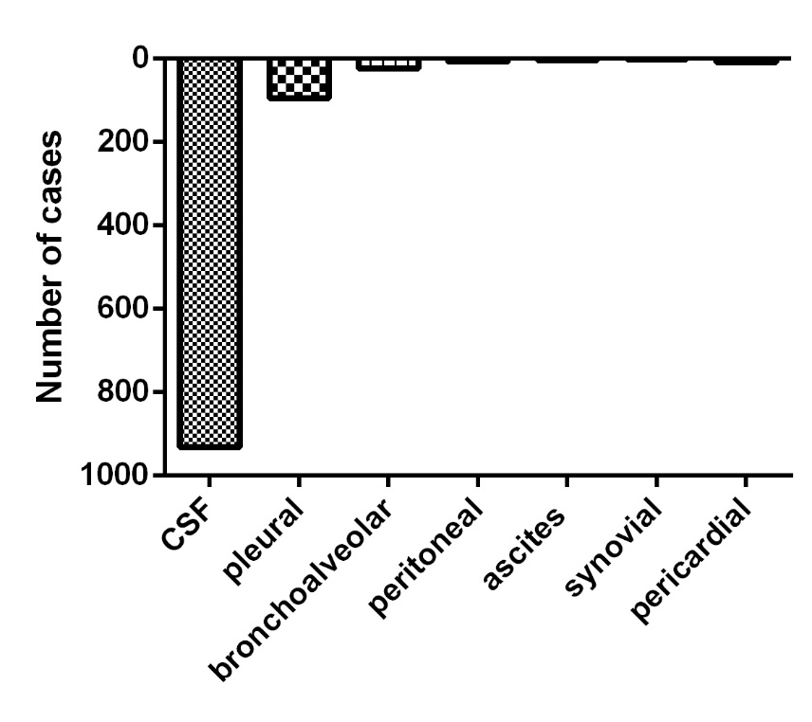

Figure 1. Distribution of cases according to the type of sample analyzed by CMF. CSF: cerebrospinal fluid; BLA: bronchoalveolar lavage.

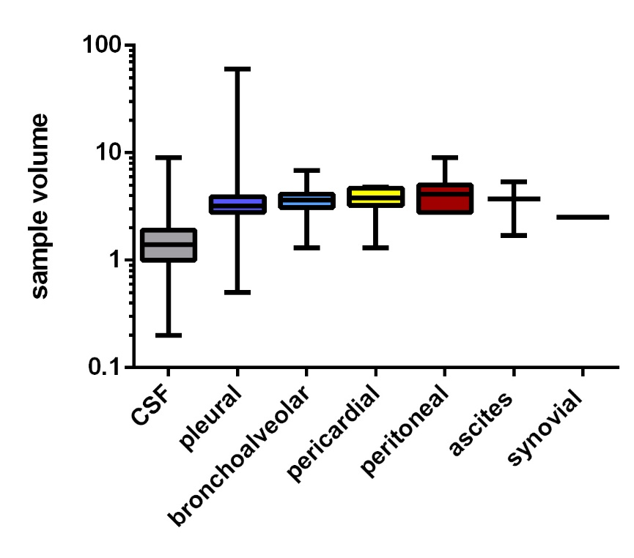
Figure 2. Sample volumes of each body fluid.
CSF: cerebrospinal fluid; BLA: bronchoalveolar lavage.

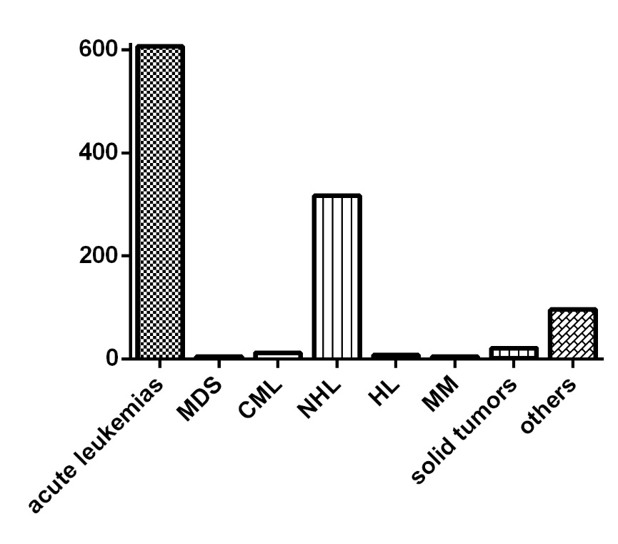
Figure 3. Distribution of cases according to the clinical question.
MDS: myelodysplastic syndrome; CML: Chronic Myelogenous Leukemia: NHL: Non-Hodgkin Lymphomas; HL: Hodgkin lymphoma; MM: multiple myeloma.

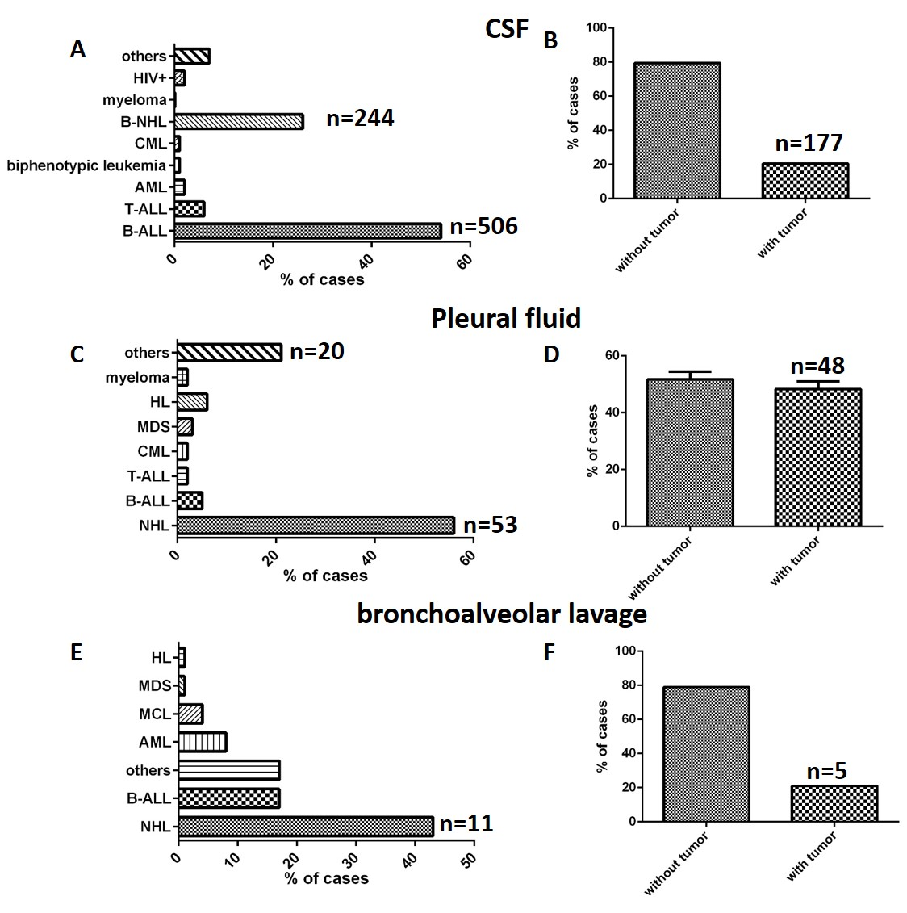
Figure 4. Types of pathologies evaluated in samples of body fluids (Panels A, C and E) and tumor infiltration results (Panels B, D and F). CSF: cerebrospinal fluid; BAL: bronchoalveolar lavage (BAL); HIV: human immunodeficiency virus, B-NHL: B-cell lymphoma, CML: chronic myeloid leukemia, AML: acute myeloid leukemia, B-ALL: acute lymphoblastic leukemia B; T-ALL: acute lymphoblastic leukemia T; LH: Hodgkin lymphoma.

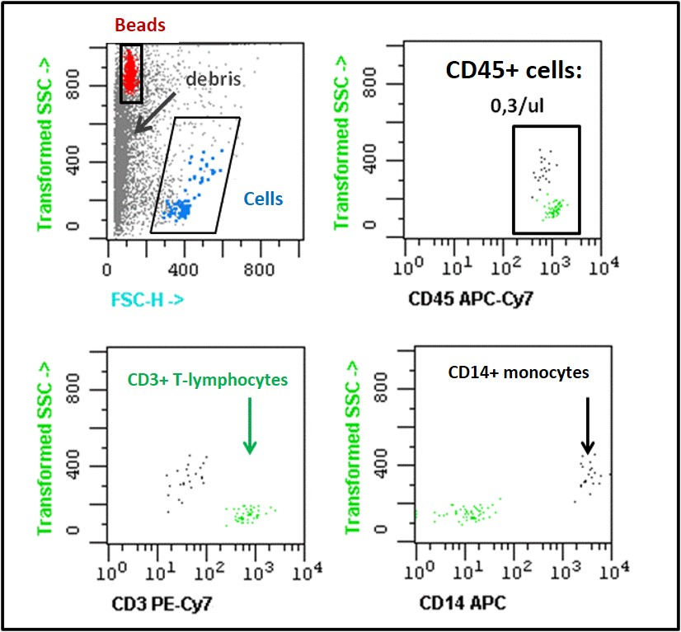
Figure 5. Illustration of bivariate dot plot histograms of a normal/reactive CSF sample from a B-cell lymphoma patient showing no CSF infiltration by multiparameter flow cytometry (FCM) immunophenotyping. In this sample, CD3+/CD45+ T cells (green dots) and CD14+/CD45 + monocytes (black dots) were detected. Gray dots represent non leukocyte events (debris) and red dots correspond to fluorescent beads.

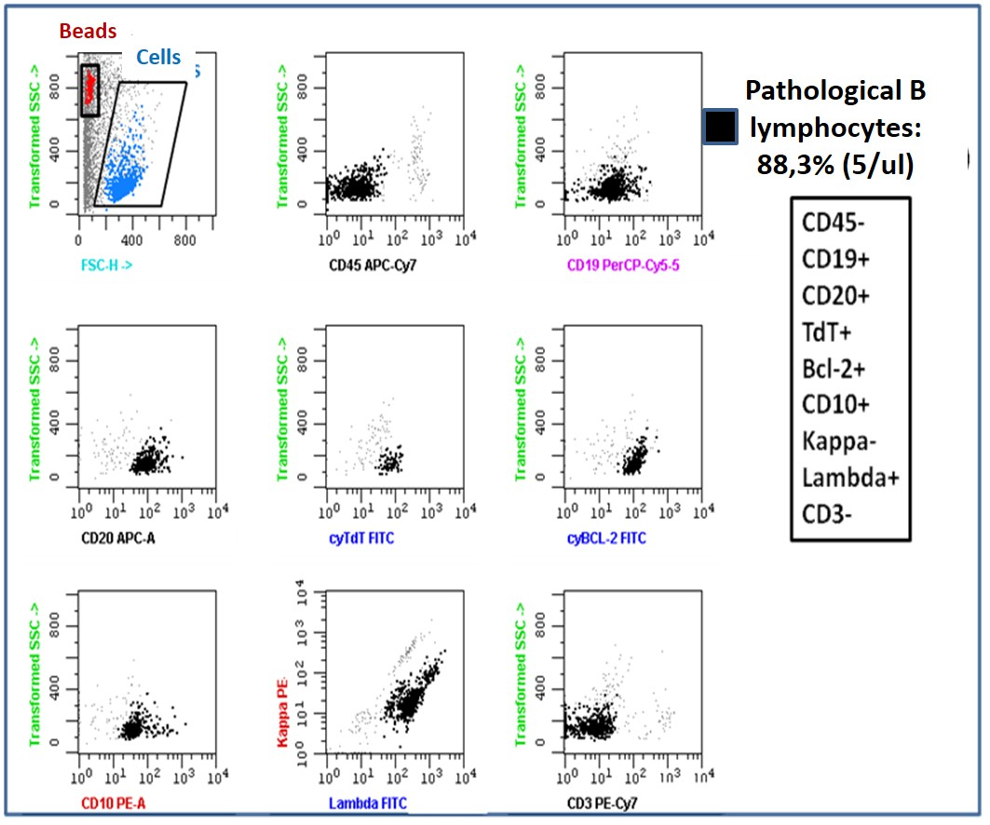
Figure 6. Identification of B tumor cells in a representative CSF sample from a B-lymphoblastic lymphoma patient. A region drawn on red events identifies beads and a second region drawn on blue events identifies total cells. The lymphoma cells (black dots) are positive for CD19, CD20, TdT, Bcl-2 and CD10. Analysis of clonality revealed monoclonal restriction of lambda light chain. Tumor cell count: 5/µl; 88.3%.

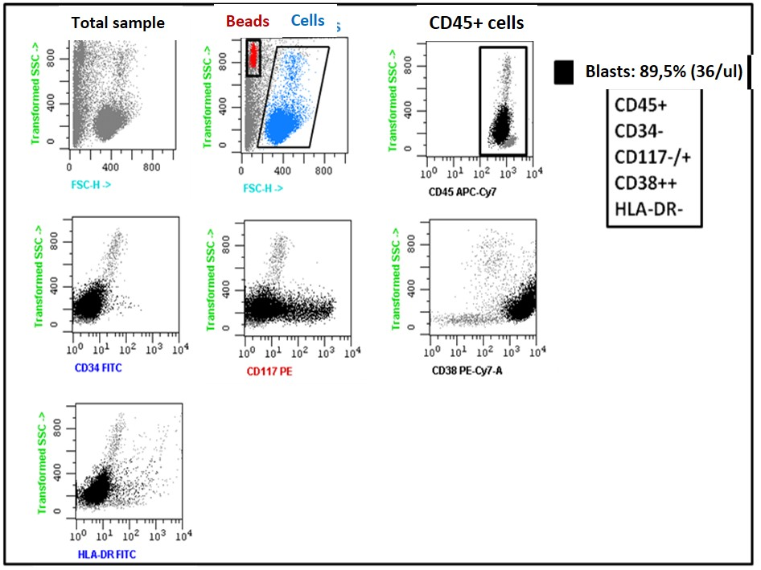
Figure 7. Illustrative example of a CSF sample from a blast crisis in a patient with chronic myeloid leukemia. For analysis, beads (red dots) and cells (blue dots) are selected. Black dots represent a large population (89.5%) of myeloid blasts with expression of CD45, CD117 and CD38. Blast cell count: 36/µl.

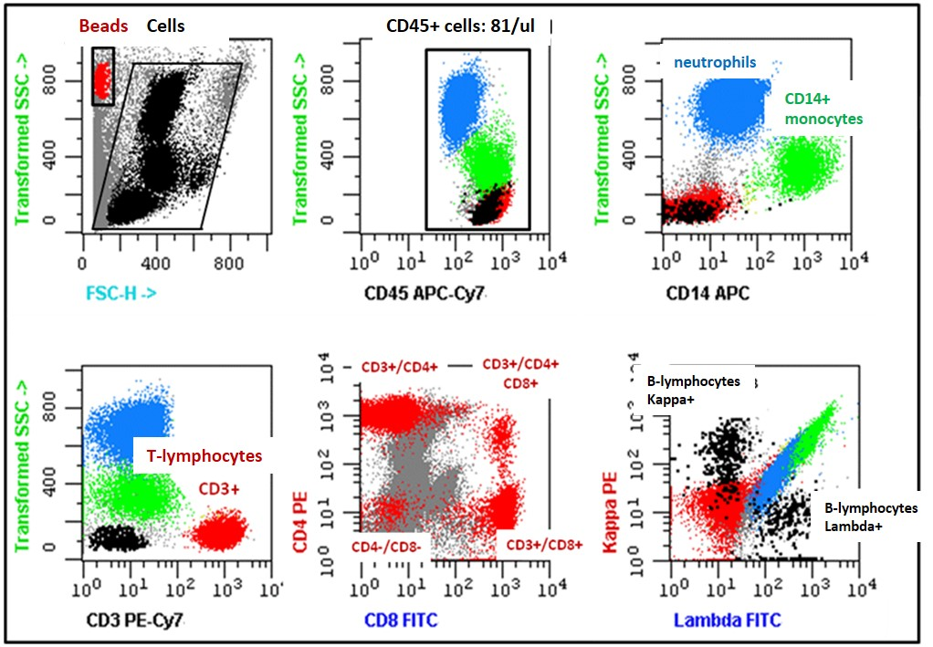
Figure 8. Illustrative example of the immunophenotypic analysis of leukocyte populations present in normal pleural fluid. For analysis, beads (red dots) and leukocytes (black dots) were selected by gating on Side Scatter –SSC- vs. Forward Scatter –FSC. Next, CD45+ leukocytes were defined by plotting events in a CD45 versus SSC dot plot. Based on differences in their physical parameters, neutrophils (blue dots), monocytes (CD14+) (green dots), T lymphocytes (CD3+, CD4+ or CD8+) (red dots) and B lymphocytes (black dots) exhibited polyclonal expression of Kappa/Lambda light chains. Total leukocyte count: 81/µl.

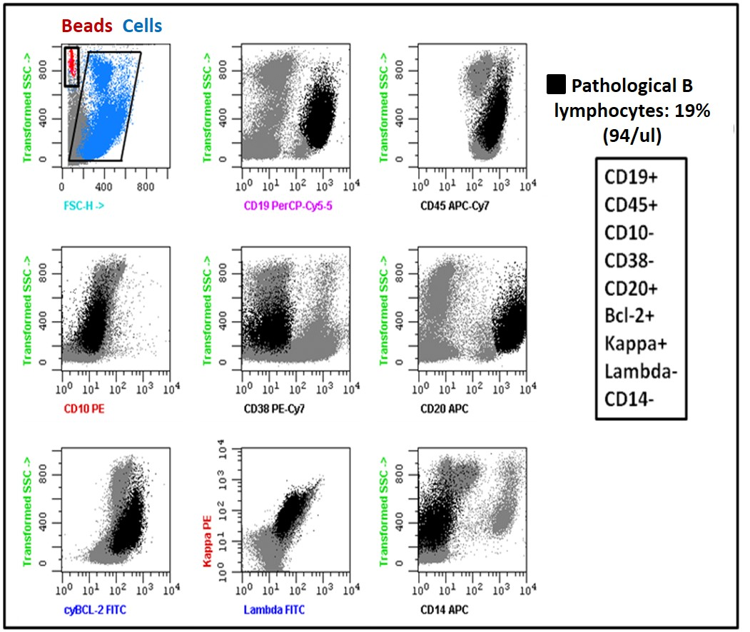
Figure 9. Example of a pleural fluid sample from a B lymphoma patient with a monoclonal B population with kappa light chain restriction blast. These cells are also positive for CD19, CD45, and CD20. A region drawn on red events identifies beads and a second region drawn on blue events identifies total cells. Tumor cell count: 94/µl; 19%.

Table 1. Design of antibody panels according to the clinical question

Clinical question | FITC | PE | PERCP | PECY7 | APC | APCCY7 | Beads
B-NHL | Lambda | Kappa | CD19 | CD3 | CD14 | CD45 | +
T-NHL | CD8 | CD4 | CD19 | CD3 | CD14 | CD45 | +
HL | CD30 | CD200 | CD3 | CD38 | CD14 | CD45 | +
B-ALL | CD34/nTdT | CD10 | CD19 | CD3 | CD14 | CD45 | +
AML | CD34 | CD117 | CD19 | CD3 | CD14 | CD45 | +
T-ALL | CD7/nTdT | CD5 | CD34 | CD3 | CD14 | CD45 | +
MDS | CD34 | CD117 | CD19 | CD3 | CD14 | CD45 | +
MM | cyLambda | cyKappa | CD19 | CD38 | CD138 | CD45 | +
Solid tumors | CD34 | CD56/CD117 | CD3 | CD38 | CD14 | CD45 | +
Others | Lambda | Kappa | CD19 | CD3 | CD14 | CD45 | +
 | CD8 | CD4 | CD19 | CD3 | CD14 | CD45 | +

Abbreviations: Cy, cytoplasmic antigen; n, nuclear antigen; FITC, fluorescein isothiocyanate; PE, phycoerythrin; PerCP, peridinin-chlorophyll-protein; PECY7, PE cyanin (Cy)7; APC, allophycocyanin; APC7, APC- cyanin (Cy)7; NHL: Non Hodgkin Lymphomas; B-ALL: B cell acute lymphoblastic leukemia; AML: acute myeloblastic leukemia; T-ALL: T cell acute lymphoblastic leukemia; MDS: myelodysplastic syndromes; Others: HIV+ patients, patients with neurological symptoms, autoimmune diseases, etc.

Table 2. Normal and tumor cell populations in special samples

Type of sample | Normal/reactive |  | Tumor infiltration |  | P value
Cerebrospinal fluid | mean | range | mean | range
Number of cells/µl | 16 | 0-3022 | 151 | 0,06-4816 | <0,01
Blast cells/µl | - | - | 71 | 0,01-1683 | NA
Pathological B lymphocytes/µl | - | - | 46 | 0,01-638 | NA
Pathological B lymphocytes/µl | - | - | 0,06 | - | NA
T lymphocytes/µl | 8 | 0-1873 | 50 | 0,02-1940 | <0,01
Monocytes/µl | 3,7 | 0-979 | 35 | 0-3477 | <0,01
Neutrophils/µl | 26 | 0-1820 | 57 | 0,03-1277 | 0,01
Pleural fluid | mean | range | mean | range | P value
Number of cells/µl | 743 | 1,1-6166 | 1648 | 0,5-11981 | 0,08
Blast cells/µl | - | - | 432 | 0,02-3214 | NA
Pathological B lymphocytes/µl | - | - | 1068 | 2-9788 | NA
Pathological B lymphocytes/µl | - | - | 360 | 298-423 | NA
Pathological plasma cells/µl | - | - | 1174 | 52-2295 | NA
Pathological CD45- cells/µl (solid tumors) | - | - | 137 | 0,8-671 | NA
CD30+ cells/µl (HL) | - | - | 0,02 | - | NA
T lymphocytes/µl | 366 | 0,4-4932 | 371 | 0,08-3399 | NS
B lymphocytes/µl | 81 | 0,01-739 | 76 | 0-1580 | NS
NK cells/µl | 30 | 0.07-393 | 12 | 0.07-47 | NS
Monocytes/µl | 91 | 0,04-471 | 163 | 0,08-2778 | NS
Neutrophils/µl | 197 | 0,06-2179 | 254 | 0,3-2932 | NS
Dendritic cells/µl | 29 | - | 2.9 | - | NA
Macrophages/µl | 83 | 0,8-352 | 20 | 1.4-41 | NS
Bronchoalveolar lavage | mean | range | mean | range | P value
Number of cells/µl | 930 | 0,6-16087 | 161 | 8-603 | NA
Blast cells/µl | - | - | 0,9 | 0,1-2 | NA
Pathological B lymphocytes/µl | - | - | 69 | 0,1-138 | NA
T lymphocytes/µl | 24 | 0,1-149 | 76 | 2,4-313 | NS
B lymphocytes/µl | 0,5 | - | 3 | 0,1-6 | NS
NK cells/µl | 1,2 | 0,4-2 | 3,3 | 0,5-6 | NS
Monocytes/µl | 80 | 0,1-563 | 58 | 0,3-118 | NS
Macrophages/µl | 88 | 34-141 | 62 | - | NA
Neutrophils/µl | 1205 | 0,7-15475 | 7,7 | 0,2-18 | NS
NA, not applicable; NS: not significant.

Table 3. Technical indications for the use of the stabilizer TransFixTM (López D 2012).
Variable | Technical Instructions for Use
Preparation | TransFixTM is added to whole sample at a ratio of 200 µl per ml (1:5).
Physical appearance of the reagent | Normal appearance of TransFixTM is that of a clear pale green liquid.
Storage | At room temperature (18 – 24ºC). TransFixTM must not be stored at 4ºC.
Evidence of Deterioration | Any change in the physical appearance of the reagent may indicate deterioration.
Type of sample | It can be used for PB, cord blood, CSF and bone marrow samples.
Type of anticoagulant used | TransFixTM can be used with all commonly used anticoagulants (K3EDTA, citrate, etc.).
Storage and stability | - 4ºC: The sample is suitable for up to 10 days after collection.  - 18-24ºC: Preservation until 7 days after collection.  - 37ºC: Stability up to 3 days.
Types of analysis | Immunophenotype by flow cytometry.  Counts of lymphocyte subpopulations, etc.

Evaluadores nacionales sugeridos:

- Nombre: John Mario González Escobar PhD
Afiliación institucional: Grupo de Ciencias Básicas Médicas Universidad de los Andes
Correo: johgonza@uniandes.edu.co

- Nombre: Alba Lucía Cómbita Rojas PhD
Afiliación institucional: Grupo de investigación en Biología del Cáncer Instituto Nacional de Cancerología
Correo: acombita@cancer.gov.co

- Nombre: Wendy Nieto PhD
Afiliación institucional: Grupo de investigación Biomédica Traslacional Fundación Cardiovascular
Correo: wnieto2005@yahoo.es

- Nombre: Martha Romero PhD
Afiliación institucional: Grupo de Patología Fundación Santa Fe de Bogotá
Correo: sanmalili@yahoo.com.ar

Evaluadores internacionales sugeridos:

- Nombre: Juan Flores Montero MD. PhD (cand)
Afiliación institucional: Servicio de citometría Centro de Investigación del Cáncer Universidad de Salamanca-España
Correo: jaflores@usal.es

- Nombre: Ricardo Duque MD.
Afiliación institucional: Bartow Regional Medical Center Florida.
Correo: redu@icloud.com

- Nombre: Elaine Sobral da Costa MD
Afiliación institucional: Departamento de Pediatría da Faculdade de Medicina da UFRJ Brasil.
Correo: elainesc@centroin.com.br

- Nombre: Juana Ciudad PhD
Afiliación institucional: Servicio de citometría Centro de Investigación del Cáncer Universidad de Salamanca-España
Correo: ciudad@usal.es

