Santa Rosa, La Pampa, January 22, 2017
Vignatti, Alicia María
Facultad de Ciencias Exactas y Naturales,
Universidad Nacional de La Pampa
aliciavignatti@cpenet.com.ar; aliciavignatti@exactas.unlpam.edu.ar

Dear Dr. Juan Carlos Salcedo Reyes

Please find enclosed for consideration the following manuscript entitled: “The ecology of saline lakes in central Argentina: Environmental and zooplankton changes during the drying of a temporary shallow ecosystem”, by Alicia María Vignatti, Maila Canosa, Gabriela Cecilia Cabrera and Santiago Andrés Echaniz.

Paradoxically, most of the articles that exists on the limnology of shallow temporary lakes in the literature, talk about the ecological dynamics at times (usually annual cycles) of relative stability. Those dealing with the dynamics of environmental and biological changes during filling or drying, moments of special interest since they allow to know environmental chemical changes and aspects of the biology of the species, are scarce worldwide.
Because one of the most important characteristics of the lakes of the central region of Argentina is their temporary character, due to its relation with the climatic cycles of “El Niño”, In this study we proposed to know the dynamics that occurred during the drying of a saline lake of La Pampa, highly representative of aquatic ecosystems in the region but different from others already studied.
In our research we found a marked decrease in depth that culminated with the drying of the lake and a gradual rise in salinity. As salinity increased, zooplankton diversity declined and even the reproduction of more tolerant species was reduced due to the environmental stress. We could verify that one of the species more frequent in the zooplankton of the region has a range of tolerance to the salinity greater than the reported to the present.

We feel this would be of interest to your audience because globally this type of studies are scarce and in Argentina this ecological processes has been described in only two lakes, both in La Pampa province. One of them was subsaline and the other one went from hipo to mesosaline, so they had higher diversity and different zooplankton assemblages. The incorporation of information on a lake that greatly exceeded the thresholds of hypersalinity, such as the one presented in this manuscript, would collaborate in knowing the ecological dynamics that takes place when surpassing salinities of 50 g.L⁻¹.

This paper has not been published previously and is not under consideration elsewhere. The authors are responsible for the reported research, and have participated in the concept and design, analysis and interpretation of data, drafting or revising of the manuscript, and have approved the manuscript as submitted. The data, models, and methodology used in the research are proprietary and comply with the legal requirements of La Pampa province, Argentina.

The authors certify that this work does not present any conflicts of interest with institutions, other authors or reviewers.

Please recommend three scientists in the field as referee:

Reviewer A: Dra. Alicia Haydeé Escalante. Universidad Nacional de Mar del Plata y Consejo Nacional de Investigaciones Científicas y Técnicas (CONICET), (Argentina). Her expertise is related to shallow saline or freshwater lakes limnology and epicontinental zooplankton and fishes taxonomy and ecology. She has also investigated ecophysiological aspects of planktonic crustaceans. aescalan@mdp.edu.ar

Reviewer B: Dra. Patricia Marta Cervellini. Universidad Nacional del Sur (Argentina). Her expertise is related to lake limnology and epicontinental zooplankton taxonomy and ecology. She also has worked with ecology and taxonomy of several marine invertebrates. pcervell@uns.edu.ar

Reviewer C: Dr. Patricio de los Ríos-Escalante. Universidad de Temuco (Chile). His expertise is related to lake limnology and epicontinental zooplankton taxonomy and ecology, with emphasis on copepods and species of Artemia. prios@uct.cl

Thank you for your consideration of my work. Please address all correspondence concerning this manuscript to me by e-mail aliciavignatti@cpenet.com.ar; aliciavignatti@exactas.unlpam.edu.ar

Sincerely,

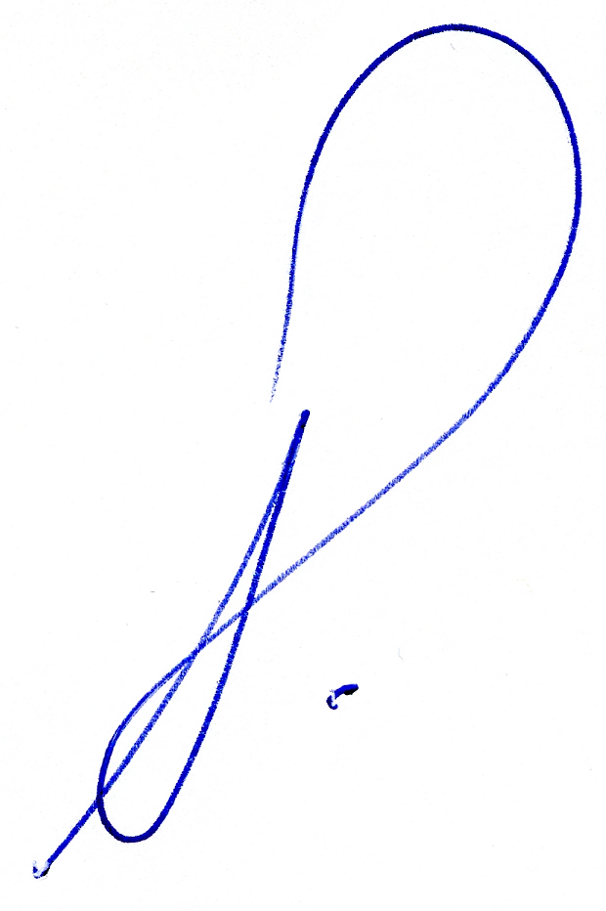

Dra. Alicia María Vignatti
Departamento de Ciencias Biológicas
Facultad de Ciencias Exactas y Naturales
Universidad Nacional de La Pampa

Attachment:
1: manuscript
2: cover letter
3: zip folder with figures in TIFF format

