The ecology of saline lakes in central Argentina: Environmental and zooplankton changes during the drying of a temporary shallow ecosystem

Alicia María Vignatti^{a*}, Maila Canosaª, Gabriela Cecilia Cabrera^{a,b} and Santiago Andrés Echanizª

ª Universidad Nacional de La Pampa, Facultad de Ciencias Exactas y Naturales, Departamento de Ciencias Biológicas, Avenida Uruguay 151, 6300, Santa Rosa, La Pampa, Argentina
^{b} CONICET (Consejo Nacional de Investigaciones Científicas y Técnicas), Avda. Godoy Cruz 2290, 1425, Ciudad Autónoma de Buenos Aires, Buenos Aires, Argentina

Abstract. In central Argentina, there are numerous saline lakes, fed by groundwater inputs and rainfall, thus, there are temporary and show changes in water level and salinity. The aim of this study was to investigate a little known ecological aspect of these lakes: environmental and zooplankton variations during drying. Monthly samples were taken from December 2012 to July 2013 in Ojo de Agua Uriburu after which time the lake dried out. At the beginning of the study period, the depth was 0.7 m and salinity was 16.65 g.L⁻¹. In July, before drying, the depth had dropped to 0.06 m and the salinity increased to 92.9 g.L⁻¹. Species richness was low (three crustaceans and three rotifers): Boeckella poopoensis dominated, followed by Moina eugeniae. Both had maximum density and biomass in April (318.5 ind.L⁻¹ and 3029.1 µg.L⁻¹ and 242.4 ind.L⁻¹ and 1530.4 µg.L⁻¹, respectively) and no correlations were found between either parameter and salinity. The maximum sizes were recorded the last time each species was found (M. eugeniae 1020 ± 84.2 µm and B. poopoensis: 1348.8 ± 89.0 µm), due to the absence of juvenile stages, probably because the increase in salinity limited reproduction. The characteristics in this lake over time differed to what has been documented in another saline lake in the region, which would justify the development of similar studies in other temporary ecosystems in order to make generalizations about these little known ecological aspects.

Keywords: temporary lakes, saline lakes, hydroperiod, zooplankton, Boeckella poopoensis, Moina eugeniae

* Address correspondence: Vignatti, Alicia-María, Universidad Nacional de La Pampa, Facultad de Ciencias Exactas y Naturales, Departamento de Ciencias Biológicas, Avenida Uruguay 151, 6300, Santa Rosa, La Pampa, Argentina; 54-02954-245220, aliciavignatti@cpenet.com.ar; aliciavignatti@exactas.unlpam.edu.ar.

- Introduction
Most water bodies in the central semi-arid region of Argentina, where the province of La Pampa is located, are shallow lakes, since their maximum depths do not exceed 3 m. Due to being located in arheic basins and being fed mainly by rainfall and phreatic inputs (the latter being the most important), these lakes are temporary and are strongly influenced by the wet and dry climate cycles caused by the “El Niño” and “La Niña” phenomena, respectively (Viglizzo, 2010; Dornes et al., 2016). This causes the lakes to be filled during rainy periods, but, during their hydroperiods, which usually last several years, the water level often decreases gradually, leading to complete drying (Echaniz & Vignatti, 2010; Vignatti et al., 2012 a, b; Echaniz et al., 2013a; Dornes et al., 2016).
Most of these temporary lakes can be considered saline lakes because the concentration of dissolved solids usually exceeds 3 g.L⁻¹ (Hammer, 1986), and there is a strong predominance of Na⁺ and Cl⁻ in its ionic composition (Echaniz, 2010). An important characteristic of these ecosystems is that changes in the water level produce considerable changes in physical and chemical parameters, especially salinity, with consequent impacts on biota, reflected in the decline in species richness as environmental stress increases (Echaniz, 2010).
At present, in La Pampa, many ecological aspects of these lakes have been studied, generally along annual cycles. This has led to the knowledge of many aspects of their ecology in relatively stable situations, since salinity variations found there have been comparatively limited (Echaniz et al., 2013a, b, 2015). There have also been studies comparing conditions recorded in different periods (annual cycles), which have shown remarkable differences in physical and chemical variables (especially in zooplankton) (Echaniz & Vignatti, 2011, Echaniz et al., 2006, 2012, 2013a, b, 2016; Vignatti et al., 2012a). However, more recently, a few studies have been carried out in La Pampa that have shown changes in the limnological parameters and in zooplankton during the filling or drying phases of some temporary environments, both subsaline (Echaniz & Vignatti, 2010) and saline (Vignatti et al., 2012a, b). However, the information is still scarce, considering that little known ecological aspects are involved, such as species replacements that accompany environmental changes of these lakes. This involves the emergence of organisms from dormant stages deposited in the sediment (egg bank). This is of particular interest, since the assemblages of species recorded in the central region of Argentina differ from those in other continents, because many endemic elements of the neotropical region are represented (Adamowicz et al., 2004; Echaniz, 2010; Echaniz et al., 2006, 2012; Vignatti, 2011; Vignatti et al., 2012b; 2016) and ecological knowledge on they is relatively scarce.
Taking the above into account, the aim of this study was to describe variations in the taxonomic composition, density, size and biomass of zooplankton and determine relationships with the main environmental parameters during the drying of a shallow, temporary and saline lake, located at the East of La Pampa province and test the following hypotheses: i) due to increased salinity, species richness is decreased throughout the study period ii) because the lake lacks predatory fish due to its saline and temporary nature, therefore zooplankton is dominated by large species and iii) zooplankton biomass is negatively affected by salinity.

- Materials and methods
Study area
The Ojo de Agua Uriburu Lake (36°31´S, 63°53´W) is located at the east of the La Pampa province, in the western limit of the phytogeographic province of the Pampa Plains (Figure 1). It is in an arheic basin and is fed by rainfall and phreatic inputs. Water level fluctuations produce large movements of the coastline, so its outline is a beach with patches of halophytic vegetation. It is surrounded by fields where cereals and oilseeds are cultivated and, to a lesser extent, cattle are bred.
During the study, the maximum length of the lake was 2351 m, the maximum width was 614 m and the maximum area was 86.8 ha (December 2012), parameters that gradually decreased until drying. In the study period, the lake lacked aquatic vegetation and fish.
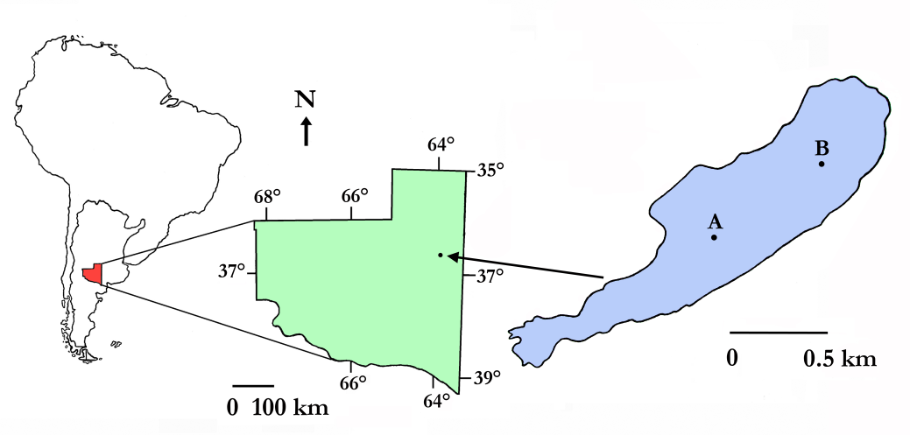
Fig. 1. Geographic location of the Ojo de Agua Uriburu Lake in the province of La Pampa (central region of Argentina). A and B indicate the sampling sites. The outline corresponds to the morphometric dimensions determined in December 2012.
Field and laboratory work
Monthly samples were taken from December 2012 to July 2013, after which time the lake dried up. Samples were taken at two sites located along the major axis of the lake (Figure 1). At each site, water temperature, dissolved oxygen concentration (Lutron™ OD 5510 oximeter), water transparency (Secchi disk), and pH (Cornning™ PS 15 peachimeter) were determined, and water samples were taken and kept refrigerated until laboratory analysis. At each site, two 20 L quantitative zooplankton samples were taken. Given the shallow depth, samples were taken with tared pails that integrated the water column, which was filtered through a net of 0.04 mm pore opening. A qualitative sample was also taken with a similar net. All samples were anesthetized with CO2 and kept refrigerated until fixation, after which they were deposited in the Facultad de Ciencias Exactas y Naturales de la Universidad Nacional de La Pampa collection.
In addition, water samples were taken for several measures: the determination of salinity by the gravimetric method with drying at 104°C; the concentration of chlorophyll-a, which was established by extraction with aqueous acetone and spectrophotometry (Arar, 1997); and the suspended solids concentration (total, organic and inorganic), which were determined by weighing of filters Microclar FFG047WPH, dried at 103–105°C to a constant weight and then calcined at 550ºC (Echaniz et al., 2012, Vignatti et al., 2016).
The macro and microzooplankton counts were made under stereoscopic and conventional optical microscopy, in Bogorov– and Sedgwick– Rafter chambers, respectively. To determine zooplankton biomass, 30 specimens of each species were measured with a micrometric Arcano 10X eyepiece and calculated using formulas that relate the total length with the dry weight for crustaceans (McCauley, 1984; Culver et al., 1985) or with geometric shapes for rotifers (Ruttner-Kolisko, 1977).
Non-parametric Spearman’s rank correlation coefficients (Zar, 1996) were calculated. We use Past (Hammer et al., 2001) and Infostat (Di Rienzo et al., 2010) softwares.

- Results
At the beginning of the study, the depth of the lake was around 0.7 m and the salinity barely exceeded 16 g.L⁻¹, but in July 2013, the depth dropped to 0.06 m and salinity increased from above 92 g.L⁻¹, before the lake dried up completely (Figure 2). The correlation between lake depth and salinity was high (r_{s} = -0.97; p = 0.0005).
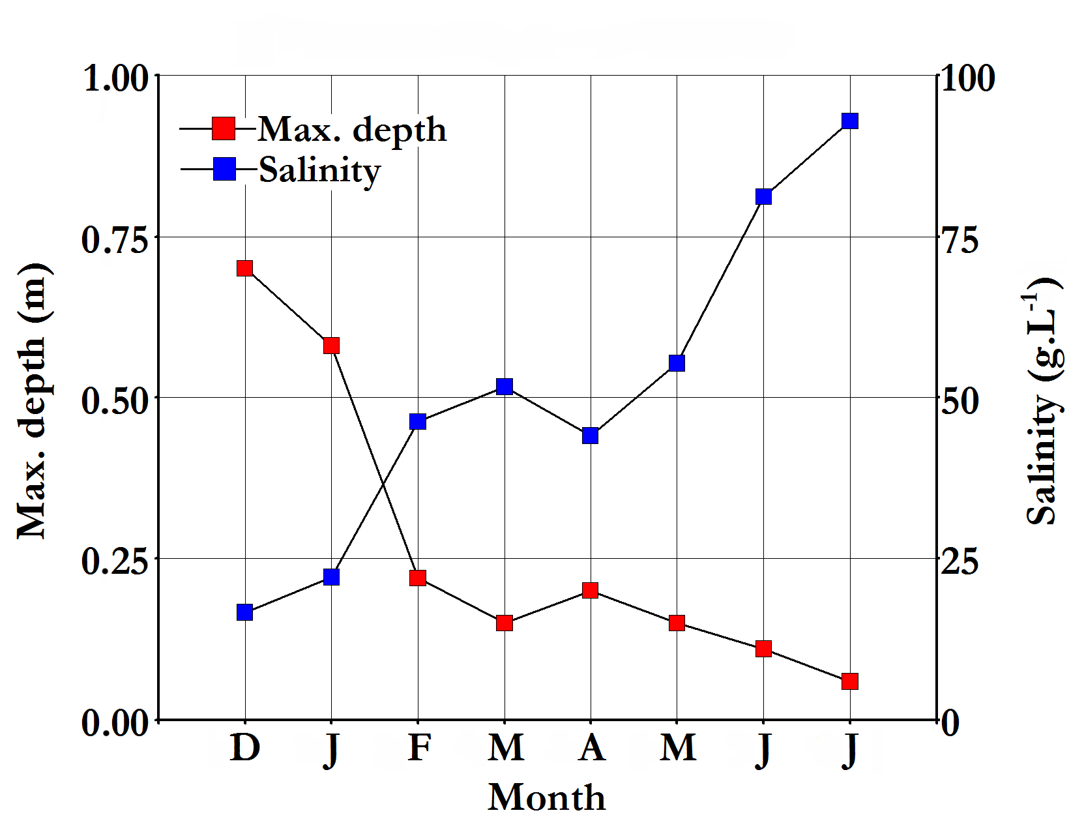
Fig. 2. Monthly variation of the maximum depth and salinity of Ojo de Agua Uriburu Lake between December 2012 and July.
Mean water pH was relatively high (Table 1) and fluctuated very little over the study period. In the chemical composition of water Cl⁻ and CO₃²⁻ predominated among the anions, which exceeded 20,000 and 14,000 mg.L⁻¹ respectively, and Na⁺ predominated among cations, which exceeded 21,000 mg.L⁻¹. The bivalent cations (Ca²⁺ and Mg²⁺) were present in lower concentrations, so the total hardness of the water was relatively low (Table 1).
Mean water temperature was around 19°C (Table 1) and showed a seasonal pattern, with a maximum of 25.7°C in January and a minimum of 10.9°C in July. The mean dissolved oxygen concentration in water was high, upper to 8 mg.L⁻¹ (Table 1), and fluctuated from a minimum of 6.7 mg.L⁻¹ (February) to a maximum of 9.9 mg.L⁻¹ (Figure 3). A correlation was found between these parameters (r_{s} = -0.87; p = 0.0077).

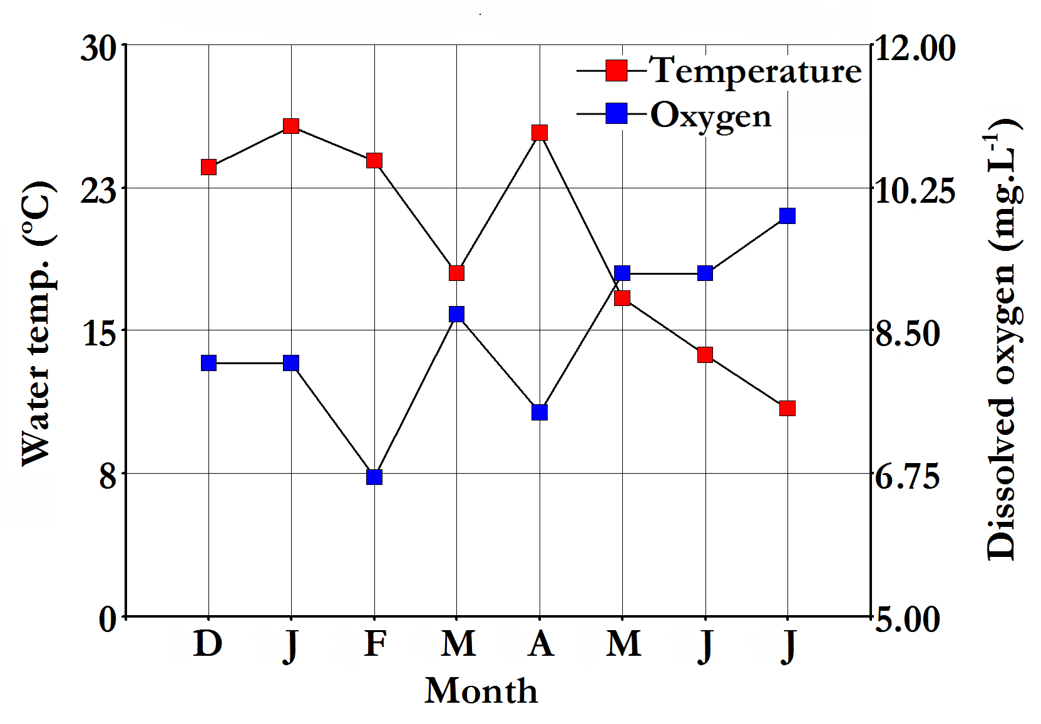
Fig. 3. Monthly variation of the water temperature and dissolved oxygen concentration in Ojo de Agua Uriburu Lake between December 2012 and July 2013.
The transparency of the water was always much reduced (Table 1) and the maximum, registered in February, was only 0.22 m (Figure 4). The phytoplankton chlorophyll-a concentration was reduced at the beginning of the study but showed a strong autumn peak that reached 104.13 mg.m⁻³ in April, after which it declined sharply (Figure 4). A significant correlation was found between water transparency and chlorophyll-a concentration (r_{s} = -0.81; p = 0.0184).

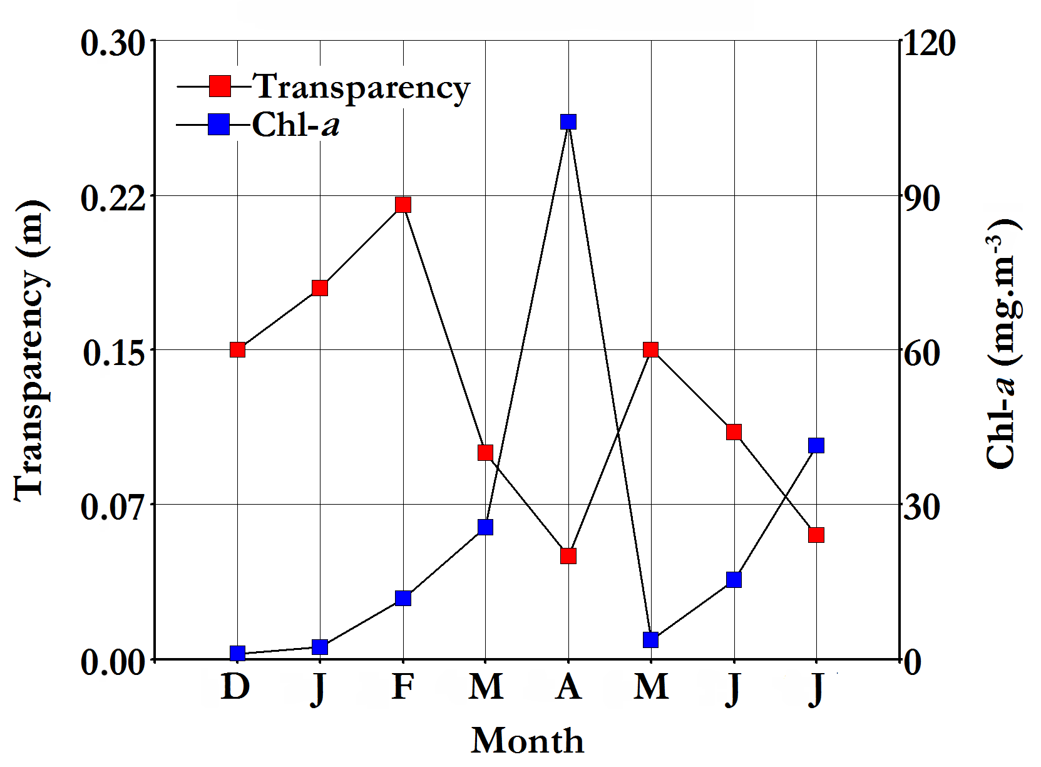
Fig. 4. Monthly variation of water transparency and chlorophyll-a concentration in Ojo de Agua Uriburu Lake between December 2012 and July 2013.
The total suspended solids amounts in the water were always relatively high, with a mean higher than 500 mg.L⁻¹ (Table 1). The correlation among water transparency and suspended solids concentration was high (r_{s} = -0.84; p = 0.0096). Solids of inorganic origin prevailed, which represented 75% of the total, while the organic solids only reached 25% (Table 1). Both showed a strong peak in autumn, especially in April, when summed, exceeded 1730 mg.L⁻¹.

Table 1: Mean and standard deviation of water physicochemical variables measured in Ojo de Agua Uriburu Lake between December 2012 and July 2013.
 | Mean (± standard deviation)
Salinity (g.L⁻¹) | 51.27 ± 24.42
Water temperature (°C) | 19.74 ± 5.32
Dissolved oxygen (mg.L⁻¹) | 8.43 ± 0.97
Transparency (m) | 0.13 ± 0.05
Chlorophyll-a (mg.m⁻³) | 25.66 ± 32.28
pH | 9.74 ± 0.21
Total suspended solids (mg.L⁻¹) | 506.20 ± 537.59
Inorganic suspended solids (mg.L⁻¹) | 380.03 ± 357.26
Organic suspended solids (mg.L⁻¹) | 126.22 ± 197.92
CO₃²⁻ (mg.L⁻¹) | 14480.01 ± 17083.68
HCO₃⁻ (mg.L⁻¹) | 2250.00 ± 3182.02
Total hardness (mg.L⁻¹) | 45.29 ± 4.61
Cl⁻ (mg.L⁻¹) | 20836.02 ± 18732.70
SO₄²⁻ (mg.L⁻¹) | 2600.00 ± 707.10
Ca²⁺ (mg.L⁻¹) | 17.69 ± 2.42
Mg²⁺ (mg.L⁻¹) | 6.71 ± 0.60
K⁺ (mg.L⁻¹) | 175.50 ± 211.41
Na⁺ (mg.L⁻¹) | 21380.00 ± 16800.89

Zooplankton richness was low and restricted to six species. A maximum of five species was found in the middle of summer; in February. However, this number declined markedly during drying, so that in July only one species was recorded. Among the crustaceans, Boeckella poopoensis was found throughout the study, even though salinity had reached values slightly above 90 g.L⁻¹, while Moina eugeniae was registered between December and May (Table 2), months at which the salinity exceeded 55 g.L⁻¹.
The rotifers were registered in the middle of summer, although in the case of Brachionus plicatilis, its presence was extended almost until late autumn (Table 2).

Table 2. Species and months in which they were recorded in the zooplankton of Ojo de Agua Uriburu Lake
 |  | D | J | F | M | A | M | J | J
Cladocerans
 | Moina eugeniae Olivier, 1954 | X | X | X | X | X | X
Copepods
 | Boeckella poopoensis Marsh, 1906 | X | X | X | X | X | X | X | X
 | Metacyclops mendocinus (Wierzejski,1892) |  | X
Rotifers
 | Hexarthra fennica (Levander, 1892) |  |  | X | X
 | Brachionus plicatilis Müller, 1786 |  |  | X |  | X
 | Brachionus dimidiatus Bryce, 1931 |  |  | X

The total density and biomass of the zooplankton community were relatively high, with a mean of 347.34 (± 341.29) ind.L⁻¹ and 1602.33 (±1485.55) µg.L⁻¹, respectively. Both parameters were correlated (r_{s} = 0.86; p = 0.0072) and showed a strong peak at the beginning of the autumn; in April they registered 1037.25 ind.L⁻¹ and 4912.3 µg.L⁻¹, respectively, after which both fell sharply (Figures 5 and 6). No correlations were found between zooplankton density or biomass with any of the environmental parameters determined. For most of the study period, both the density and biomass of the zooplankton of the lake were dominated by copepods (Figures 5 and 6). However, in February, density was dominated by rotifers (Figure 5), due to a peak of abundance of Hexarthra fennica that reached 305.8 ind.L⁻¹, and the biomass was dominated by cladocerans (Figure 6), particularly by the contribution of Moina eugeniae that reached 726.6 µg.L⁻¹. Among the copepods, Boeckella poopoensis dominated and throughout the study showed a mean density of 114.8 ind.L⁻¹ (± 109.3) and a biomass of 1039.2 µg.L⁻¹ (± 954.6). This species had a peak in April when it reached 318.5 ind.L⁻¹ and 3029.1 µg.L⁻¹ and was the only species recorded in June and July.

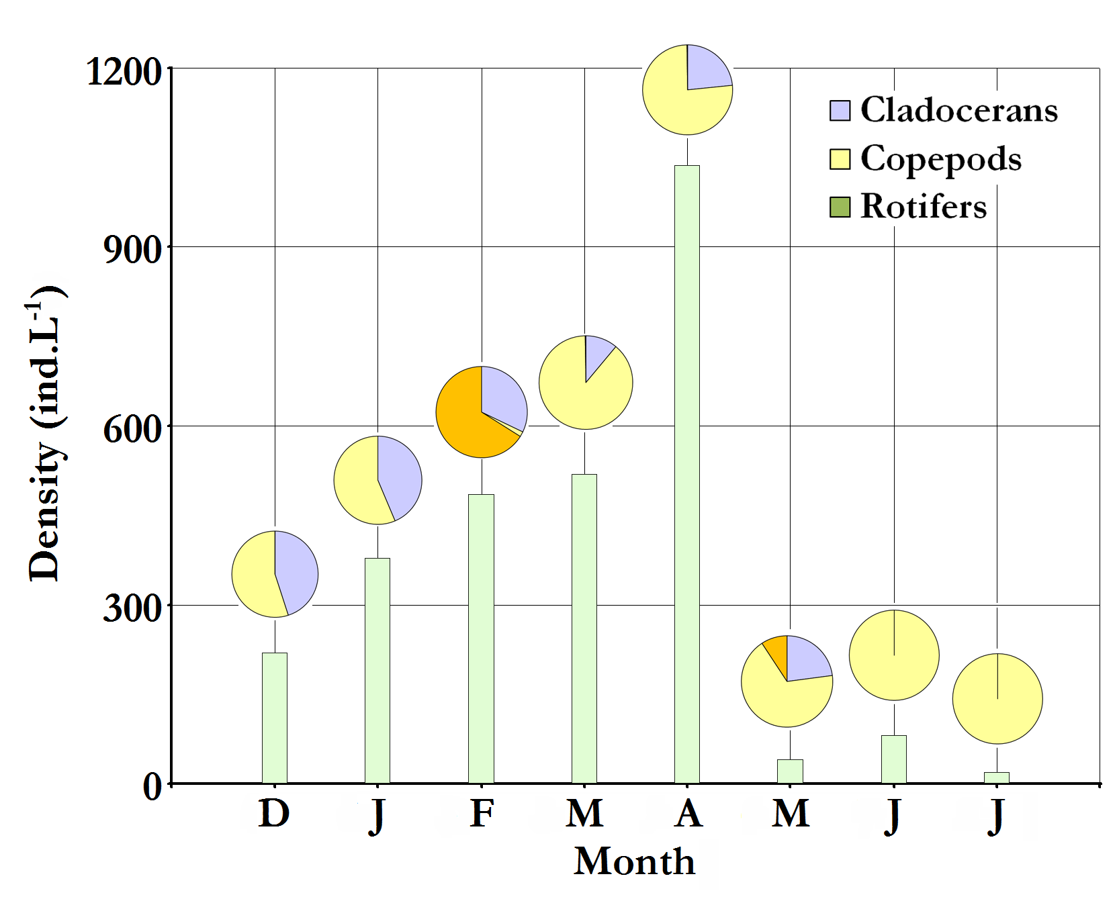
Fig. 5. Monthly variation of the total zooplankton density (bars) and by taxonomic group (circles) in Ojo de Agua Uriburu Lake between December 2012 and July 2013.

Fig. 6. Monthly variation of the total zooplankton biomass (bars) and by taxonomic group (circles) in Ojo de Agua Uriburu Lake between December 2012 and July 2013.

The sizes of the two most important crustaceans, M. eugeniae and B. poopoensis showed a similar pattern. Between December and March their mean lengths were 803.4 (± 27.4) µm and 933.0 (± 39.9) µm but from that moment they increased and greater corporal sizes were recorded in May for M. eugeniae (1020 ± 84.2 µm) and in June for B. poopoensis (1348.8 ± 89.0 µm), the last time that each one was recorded (Figure 7).

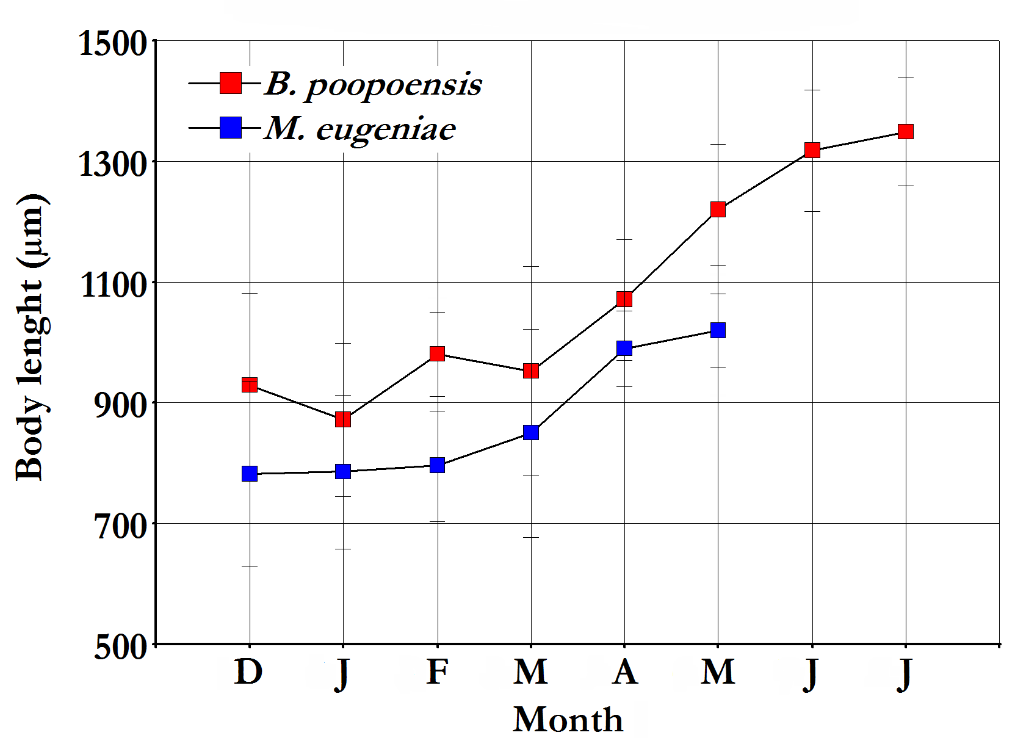
Fig. 7. Variation in the mean length of B. poopoensis and M. eugeniae, the two most important crustaceans, throughout the study.

- Discussion
Most shallow lakes in central Argentina, especially those located in the province of La Pampa, are temporary and their filling and drying depend on climatic cycles (Viglizzo, 2010). Thus, it is frequent that during rainy cycles associated with the ENSO (El Niño Southern Oscillation) phenomenon, most lakes are filled, starting hydroperiods of variable duration. If the period with precipitation above mean values is relatively prolonged, there is an increase in the amount of water stored in the soil, with a consequent rise in the piezometric level. Groundwater discharges that occur in low-lying areas, where temporary lakes are located, constitutes the main source of lake water, surpassing the quantities that enter directly by rain or surface runoff (Dornes et al., 2016). This means the duration of hydroperiods in these lakes are closely related to the amount of water that has been stored in the ground and may, in some cases, extend over several years (Echaniz et al., 2013a, b). In the case of Ojo de Agua Uriburu, which had remained filled for at least ten years, dried completely after July 2013 and remained that way until the end of 2015 when it was filled again due to the beginning of a new period of abundant rainfall (Vignatti & Echaniz, pers. obs.).
The lake water was chloride-carbonate sodic and its hardness was reduced, given the low concentrations of bivalent cations. At the beginning of the study, the lake was characterized as hyposaline, due to a recorded salinity of less than 20 g.L⁻¹ (Hammer, 1986). However, only three months later, the process of salt concentration that accompanied the evaporation of water caused the salinity to exceed 50 g.L⁻¹, passing to the hypersaline interval (Hammer, 1986), in which it was maintained until drying. These salinity changes mean that the allocation of these lakes to a specific category is of relative utility and must be considered with precaution, since they depend on the moment of hydroperiod studied. Both the chemical composition and the salt concentration confirm that the lake chemistry is governed by evaporation-crystallization, as is the case in most lakes of the Central Chaco region of Argentina (Echaniz, 2010).
The transparency of the water was relatively low, which could be due to the high amount of suspended solids, especially those of inorganic origin. This is a common situation in lakes in this region: because they are in flat landscapes, their shallow depth, relatively flat bottoms, and the frequent winds of the region, sediment resuspensions from the bottom are very frequent, as has been recorded in several lakes of central La Pampa (Echaniz, 2010; Echaniz & Vignatti, 2013; Echaniz et al., 2013a; Vignatti et al., 2012a;). An exception could have occurred in April, when the low transparency coincided with the phytoplankton chlorophyll-a peak that exceeded 100 mg.m⁻³. In this sense, the high concentration of dissolved oxygen that was determined in the water, even in cases where the concentration of chlorophyll was relatively reduced, was probably more due to dissolution from the atmosphere favored by turbulence generated by the wind than to the contributions of phytoplankton autotrophic organisms. This is a frequent phenomenon in clear lakes of La Pampa, such as El Carancho, Utracán or La Amarga, where in spite of the fact that in 2007 chlorophyll-a concentrations were very low (< 1.5 mg.m⁻³) the concentrations of dissolved oxygen were above 9.5 mg.L⁻¹ (Vignatti et al., 2012b; Vignatti & Echaniz, unpublished data).
A particular feature of Ojo de Agua Uriburu is that the water temperature in winter was not as low as in other shallow lakes in the region, where values below 6°C have been recorded (Vignatti et al., 2012b; Vignatti & Echaniz, unpublished data). This could be due to the large amount of inorganic suspended solids that gave the water an intense dark brown color. This would allow the small volume of water contained in the basin to be heated by solar radiation, similar to what was found in the Aime and Estancia Pey-Ma Lakes (two lakes of similar characteristics to Ojo de Agua Uriburu), where the large amount of inorganic solids gave the same appearance to the water and where the winter temperature was above 9°C (Vignatti et al., 2012a; Echaniz et al., 2013a).
The zooplankton richness of Ojo de Agua Uriburu was low and part of the typical association of saline lakes without fish in central Argentina (Vignatti, 2011; Vignatti et al., 2012a, 2012b, 2016; Echaniz, 2010; Echaniz et al., 2006, 2013a, 2013b, 2015, 2016); characterized by the presence of the endemic neotropical halophilic crustaceans Boeckella poopoensis and Moina eugeniae and the rotifers Hexarthra fennica and Brachionus plicatilis. However, in this case, these are cosmopolitan species and of extensive distribution given their wide tolerance to salinity (Fontaneto et al., 2006; Echaniz et al., 2016). The modulatory effect of salinity on the zooplankton community was highlighted by the fact that richness was higher at the beginning of the study and declined markedly towards the end, so that in the last two months, when the dissolved solids concentration exceeded 80 g.L⁻¹, only the halotolerant B. poopoensis was found.
It is important to note that, until now, M. eugeniae has always been recorded within the hypo-mesosaline range and it was in the Pey-Ma Lake where it was registered with the highest salinity (close to 48 g.L⁻¹) (Echaniz et al., 2013a), so the present study is the first record for this species in the hypersaline range.
The larger sizes of both B. poopoensis and M. eugeniae, which were recorded towards the end of the study, could be due to an increase in environmental stress produced by increased salinity that would negatively influence reproduction. This would explain the lack of juvenile specimens, such as M. eugeniae in March and April or nauplii larvae of B. poopoensis in June and July.
Although the largest zooplankton was recorded during the last two months, its biomass was lower than that found in previous months, because the density was also lower, mainly due to the absence of juvenile stages. However, the absence of significant statistical correlations does not confirm the existence of a negative influence exerted by the increase of salinity on these biological parameters.
A characteristic common to many shallow lakes of the region is that the combination of their temporary nature and their high salinity make their colonization by fish difficult. This situation, which was also verified in Ojo de Agua Uriburu, allowed crustaceans of relatively large size to appear in the zooplankton, such as B. poopoensis and M. eugeniae, the latter generally absent in lakes where zooplankivorous fish are recorded. The presence of this species could explain the low concentrations of chlorophyll-a of this lake: although it is considered that grazers have a greater influence on decreasing the amount of phytoplankton belonging to the genus Daphnia (Muylaert et al., 2006; Boveri & Quirós, 2007; Echaniz et al., 2010), M. eugeniae is of relatively large size and, since it feeds mainly in the water column, their grazing on phytoplankton could be of relative importance (Echaniz, 2010).
Although the drying process was studied in Aime Lake, a hypo-mesosaline ecosystem of the province (Vignatti et al., 2012a), which shares some characteristics with Ojo de Agua Uriburu, such as the reduced transparency of water caused by sediment in suspension, the ecological aspects were very different during drying from what was found in this study. While in Ojo de Agua Uriburu, the richness was very low and the density fell towards the end, in Aime Lake the species richness was much higher (16 taxa) and salinity barely exceeded 23 g.L⁻¹ in the pre-drying sampling, when density showed a peak that exceeded 29,000 ind.L⁻¹, caused by rotifers. This comparison confirms that there exists a remarkable variation in the ecology of saline lakes of the central region of Argentina, making it relatively difficult to establish generalizations about their functions. To obtain more useful information on these little known ecological aspects, it is necessary to carry out further studies both during filling and drying of other water bodies, which, despite having some similar characteristics, may differ in their function.

- Conclusions
In Central Argentina the lakes are strongly influenced by wet and dry climate cycles, therefore, they are temporary. At present, many ecological aspects have been studied, generally along relatively stable periods. However, changes occurring during filling or drying, the more interesting moments, are not well known.
The Ojo de Agua Uriburu Lake, located at the east of the La Pampa province, is in an arheic basin and fed by rainfall and phreatic inputs. In December 2012 its depth was 0.7 m and the salinity close to 16 g.L⁻¹, but in July 2013, the depth dropped to 0.06 m and salinity increased from above 92 g.L⁻¹, before the lake dried up completely.
Due to salinity, zooplankton richness was restricted to six halotolerant species and the endemic neotropical crustaceans Boeckella poopoensis and Moina eugeniae were dominant.
At present, only the drying of two other lakes in the region had been studied, but as its salinity was lower, the richness found was higher and relatively different. This comparison confirms the high variation in the ecology of saline lakes of the central region of Argentina, making it relatively difficult to establish generalizations about their functions and that more studies are needed.

- Conflict of interest
The authors certify that this work does not present any conflicts of interest.

References
Adamowicz S, Hebert P, Marinone MC. Species diversity and endemism in the Daphnia of Argentina: a genetic investigation, Zoological Journal of the Linnean Society, (140): 171-205, 2004.
doi: 10.1111/j.1096-3642.2003.00089.x
Arar EJ. In vitro determination of chlorophylls a, b, c + c and pheopigments in marine and freshwater algae by visible spectrophotometry. Method 446.0. U.S. Environmental Protection Agency, 1997.
Boveri M, Quirós R. Cascading trophic effects in pampean shallow lakes: results of a mesocosm experiment using two coexisting fish species with different feeding strategies, Hydrobiologia, 584: 215-222, 2007.
doi: 10.1007/s10750-007-0581-1
Culver D, Boucherle M, Bean D, Fletcher J. Biomass of freshwater crustacean zooplankton from length-weight regressions, Canadian Journal of Fisheries and Aquatic Sciences, 42(8): 1380-1390, 1985.
doi: 10.1139/f85-173
Di Rienzo JA, Casanoves F, Balzarini MG, González L, Tablada MC, Robledo W. InfoStat (version 2010). Group InfoStat, Facultad de Ciencias Agropecuarias, Universidad Nacional de Córdoba, Argentina, 2010.
Dornes P, Comas R, Cardín D, Pochetti R, Ianni J, Kruse E. Identificación y caracterización hidrológica de lagunas en el centro-este de la Provincia de La Pampa. In García R, Rocha V, Dornes P, editors. Relación Agua Subterránea-Superficial. Actas del IX Congreso Argentino de Hidrogeología - VII Seminario Hispano Latinoamericano de Hidrología Subterránea, San Fernando del Valle de Catamarca, 213-220, 2016.
Echaniz S. Composición y abundancia del zooplancton en lagunas de diferente composición iónica de la provincia de La Pampa. Tesis Doctoral. Facultad de Ciencias Exactas, Físico Químicas y Naturales, Universidad Nacional de Río Cuarto. 169 p. 2010.
Echaniz SA, Vignatti AM, José de Paggi S, Paggi JC, Pilati A. Zooplankton seasonal abundance of South American saline shallow lakes, International Review of Hydrobiology, 91(1): 86-100, 2006.
doi: 10.1002/iroh.200510803
Echaniz S, Vignatti A. Diversity and changes in the horizontal distribution of crustaceans and rotifers in an episodic wetland of the central region of Argentina, Biota Neotropica, 10(3): 133-141, 2010.
doi: 10.1590/S1676-06032010000300014
Echaniz SA, Vignatti AM, José de Paggi SB, Cabrera GC. El modelo de estados alternativos de lagos someros en La Pampa: comparación de Bajo de Giuliani y El Carancho. Libro del 3° Congreso Pampeano del Agua, 45-53, 2010.
http://www.lapampa.gov.ar/images/stories/Archivos/RecursosHidricos/Libro_III_Congreso_del_Agua.pdf
Echaniz SA, Vignatti AM. Seasonal variation and influence of turbidity and salinity on the zooplankton of a saline lake in central Argentina, Latin American Journal of Aquatic Research, 39(2): 306-315, 2011.
doi: 10.3856/vol39-issue2-fulltext-12
Echaniz SA, Vignatti AM, Cabrera GC, José de Paggi SB. Zooplankton richness, abundance and biomass of two hypertrophic shallow lakes with different salinity, Biota Neotropica, 12(2): 37-44, 2012.
doi: 10.1590/S1676-06032012000200005
Echaniz SA, Vignatti AM. Trophic status of shallow lakes of La Pampa (Argentina) and its relation with the land use in the basin and nutrient internal load, Journal of Environmental Protection, 4: 51-60, 2013 (Special Issue on Eutrophication).
doi: 10.4236/jep.2013.411A1007
Echaniz SA, Cabrera GC, Rodríguez C, Vignatti AM. Do temporary lakes vary from year to year? A comparison of limnological parameters and zooplankton from two consecutive annual cycles in an Argentine temporary saline lake, International Journal of Aquatic Science, 4 (1): 44-61, 2013a.
http://www.journal-aquaticscience.com/2013%20(1)/Echaniz%20et%20al.%20(2013)_1.pdf
Echaniz SA., Cabrera GC, Aliaga PL, Vignatti AM. Variations in zooplankton and limnological parameters in a saline lake of La Pampa, central Argentina, during an annual cycle, International Journal of Ecosystem, 3(4): 72-81, 2013b.
doi: 10.5923/j.ije.20130304.03
Echaniz SA, Cabrera GC, Vignatti AM. The ecology of the saline lakes in the semiarid Pampa central (Argentina): limnological characterization and zooplankton of Utracán, Advances in Life Sciences, 5(3): 64-72, 2015.
doi: 10.5923/j.als.20150503.03
Echaniz S, Vignatti A, Cabrera G, Capecce C, Treffinger Cienfuegos MS. Comparación de los parámetros limnológicos y el zooplancton de un lago somero salino de La Pampa (Argentina) durante dos ciclos anuales de condiciones diferentes. Biología Acuática, 31: 28-39, 2016.
http://sedici.unlp.edu.ar/bitstream/handle/10915/56481/Documento_completo.pdf-PDFA.pdf?sequence=1
Fontaneto D, De Smet W, Ricci C. Rotifers in saltwaters, re-evaluation of an inconspicuos taxon, Journal of the Marine Biological Association of the United Kingdom, 86: 623-656, 2006.
doi: 10.1017/S0025315406013531
Hammer U. Saline Lake Ecosystems of the World. Monographiae Biologicae 59. Dr. W. Junk Publishers, Dordrecht. 616 p. 1986.
Hammer Ø, Harper D, Ryan P. PAST: Paleontological Statistics Software Package for Education and Data Analysis, Palaeontologia Electronica, 4(1): 1-9, 2001.
http://palaeo-electronica.org/2001_1/past/past.pdf
McCauley E. The estimation of the abundance and biomass of zooplankton in samples. In Downing J, Rigler F, editors. A manual on methods for the assessment of secondary productivity in freshwaters. Second edition. Blackwell Scientific Publications, Oxford, 228-265, 1984.
Muylaert K, Declerck S, Van Wichelen J, De Meester L, Vyverman W. An evaluation of the role of daphnids in controlling phytoplankton biomass in clear water versus turbid shallow lakes, Limnologica 36: 69-78, 2006.
doi: 10.1016/j.limno.2005.12.003
Ruttner-Kolisko A. Suggestions for biomass calculation of plankton rotifers, Archiv für Hydrobiologie-Beiheft Ergebnisse der Limnologie, (8): 71-76, 1977.
Viglizzo EF. El agro, el clima y el agua en La Pampa semiárida: revisando paradigmas, Anales de la Academia Nacional de Agronomía y Veterinaria (ANAV) LXIV, 251-267, 2010. http://sedici.unlp.edu.ar/bitstream/handle/10915/27600/Documento_completo.pdf?sequence=1.
Vignatti AM. Biomasa del zooplancton en lagunas salinas y su relación con la concentración de sales en ausencia de peces. Tesis Doctoral. Facultad de Ciencias Exactas, Físico Químicas y Naturales, Universidad Nacional de Río Cuarto. 220 p. 2011.
Vignatti A, Cabrera G, Echaniz S. Changes in the zooplankton and limnological variables of a temporary hypo-mesosaline wetland of the central region of Argentina during the drying, Pan American Journal of Aquatic Sciences, 7(2): 93-106, 2012a.
http:// http://www.panamjas.org/pdf_artigos/PANAMJAS_7(2)_93-106.pdf
Vignatti A, Paggi JC, Cabrera G, Echaniz S. Zooplankton diversity and its relationship with environmental changes after the filling of a temporary saline lake in the semi-arid region of La Pampa (Argentina), Latin American Journal of Aquatic Research, 40(4): 1005-1016, 2012b.
doi: 103856/vol40-issue4-fulltext-16
Vignatti AM, Cabrera GC, Echaniz SA. Biology of Boeckella poopoensis Marsh, 1906 (Copepoda, Calanoida) in natural conditions in temporary saline lakes of the central Argentina, Biota Neotropica, 16(2): e20150063, 2016.
doi: 10.1590/1676-0611-BN-2015-0063
Zar JH. Biostatistical analysis. 3º Ed. Prentice Hall, New Jersey. 988 p. 1996.

La ecología de los lagos salinos del centro de Argentina: Cambios ambientales y en el zooplancton durante el secado de un ecosistema somero temporario

Resumen
En el centro de Argentina hay numerosos lagos salinos, alimentados por aportes freáticos y precipitaciones; por lo que son temporarios y sufren cambios de nivel y salinidad. El objetivo fue estudiar un aspecto ecológico poco conocido: variaciones ambientales y del zooplancton durante el secado. Se muestreó mensualmente (diciembre 2012 - julio 2013), en “Ojo de Agua Uriburu”, ya que posteriormente el lago se secó. Al inicio la profundidad fue 0,7 m y la salinidad 16,65 g.L⁻¹. En julio, antes del secado, la profundidad había descendido a 0,06 m y la salinidad aumentó hasta 92,9 g.L⁻¹. La riqueza fue baja (tres crustáceos y tres rotíferos). Predominó Boeckella poopoensis, seguida por Moina eugeniae. Ambas tuvieron máximas densidades y biomasas en abril (318.5 ind.L⁻¹ y 3029.1 µg.L⁻¹ y 242,4 ind.L⁻¹ y 1530.4 µg.L⁻¹ respectivamente) y no se encontró correlación entre ambos parámetros y la salinidad. Las tallas máximas se registraron la última ocasión en que cada una fue hallada (M. eugeniae 1020 ±84.2 µm y B. poopoensis: 1348.8 ±89.0 µm), debido a la ausencia de estadios juveniles, probablemente debido a que el aumento de la salinidad limitó la reproducción. Lo ocurrido en este lago difirió a lo documentado en otro lago salino de la región, lo que y justificaría el desarrollo de estudios similares en otros cuerpos de agua temporarios a efectos de hacer generalizaciones sobre estos aspectos ecológicos no muy conocidos.

Palabras clave: lagos temporarios, lagos salinos, hidroperíodo, zooplancton, Boeckella poopoensis, Moina eugeniae

A ecologia dos lagos salinos do centro da Argentina: Mudanças ambientais e no zooplâncton durante a secagem de um ecossistema superficial temporário

Resumo
No centro da Argentina há inúmeros lagos salinos que são alimentados por aportes freáticos e precipitações; razão pela qual são temporários e sofrem alterações de nível e salinidade. O objetivo foi estudar um aspecto ecológico pouco conhecido: variações ambientais e do zooplâncton durante a secagem. As amostras foram mensais (entre dezembro 2012 - julho 2013), em “Ojo de Agua Uriburu”, já que posteriormente o lago secou. No início, a profundidade foi de 0,7 m e a salinidade de 16,65 g.L⁻¹. Em julho, antes da secagem, a profundidade havia descendido para 0,06 m e a salinidade aumentou até 92,9 g.L⁻¹. A riqueza foi baixa (três crustáceos e três rotíferos). Houve predomínio de Boeckella poopoensis, seguida de Moina eugeniae. Ambas tiveram máximas densidades e biomassas em abril (318.5 ind.L⁻¹ e 3029.1 µg.L⁻¹ e 242,4 ind.L⁻¹ e 1530.4 µg.L⁻¹ respectivamente) e não foi encontrada correlação entre ambos os parâmetros e a salinidade. As medidas máximas foram registradas na última ocasião em que cada uma delas foi achada (M. eugeniae 1020 ±84.2 µm e B. poopoensis: 1348.8 ±89.0 µm), ocasionado pela ausência de estados juvenis, provavelmente devido a que o aumento da salinidade limitou a reprodução. O ocorrido neste lago diferiu do documentado em outro lago salino da região, o que justificaria o desenvolvimento de estudos similares em outros corpos d’água temporários para estabelecer generalizações sobre estes aspectos ecológicos pouco conhecidos.

Palavras chave: lagos temporários, lagos salinos, hidroperíodo, zooplancton, Boeckella poopoensis, Moina eugeniae

